WEBSITE CONTENT · SERVICE ARCHITECTURE · PRICE LIST
Every treatment starts with a diagnosis.

Contents
How to use this document 4
Part 1 — Strategy on one page 6
1.1 The promise 6
1.2 Who the site serves 6
1.3 Price position: upper-middle to premium, earned by inclusions 7
1.4 Voice rules 7
Part 2 — From the service list to the website 8
Part 3 — Site map and interlinking pathways 12
3.1 Navigation 12
3.2 Page tree 12
3.3 Seven patient pathways 14
3.4 Linking rulebook 14
3.5 The commitment ladder 14
Part 4 — Behavioural design and choice architecture 16
4.1 Principles built into pages and prices 16
4.2 Built for Bangladesh 17
4.3 Tactics we never use 17
Part 5 — Page-by-page copy 18
5.1 Home 18
5.2 About Dr. Sumya Pervin 19
5.3 The Centre — tour and team 20
5.4 Current chambers (until the Centre opens) 21
5.5 Medical Dermatology hub 21
5.18 Skin Surgery & Procedures hub 35
5.25 Before and after your procedure (patient guide) 40
5.26 Aesthetic & Laser hub 41
5.36 Bridal & Groom programmes 49
5.37 Prices page 49
5.38 What we don’t offer 50
5.39 Skin care products and the skin type guide 51
5.40 Tools, booking and visit preparation 51
Part 6 — Master price list (proposed) 53
6.1 Consultations (all with Dr. Sumya) 53
6.2 Six-month Care Plans (offered only after diagnosis) 53
6.3 Tests and diagnostics 54
6.4 Skin surgery and procedures 54
6.5 Aesthetic treatments 55
6.6 Laser and light 55
6.7 Bridal and Groom programmes 56
6.8 Pricing policies (publish on /prices#policies and /terms) 56
6.9 How the price list influences choice, and why it stays ethical 57
Part 7 — Sample page layouts 58
7.1 Home page 58
7.2 Prices page 62
7.3 Mobile rules (most Dhaka health searches are on mobile) 64
Part 8 — Global-standard checklist 66
Part 9 — Decisions for Medical Director sign-off 67

Facts already confirmed and used as written
- Name and title: Dr. Sumya Pervin, Consultant Dermatologist — Skin, Hair, Nail, Allergy & Venereal Diseases.
- Qualifications: MBBS (SSMC, 2011) · DDV (BSMMU, 2019) · FCPS — Skin & VD (BCPS, 2025) · trained in dermatosurgery · BMDC Reg. No. A-59492.

Part 1 — Strategy on one page

1.1 The promise
Specialist dermatology, diagnosis first — with prices you can see and a plan you can follow.
Dhaka patients choose between two flawed options. The hospital OPD has sound medicine, but you wait two hours for six minutes. The beauty clinic has excellent hospitality, but no dermatologist is in the room and the price changes once you sit down. This practice is the third option: hospital-grade clinical judgement, delivered on time, explained fully, priced in the open and followed up.
Brand pillar | Proof the website must show | Market pain it answers
Diagnosis before treatment | Published 5-step consultation; “tests only if they change treatment”; no prescribing from photos. | “They sold me a package for simple acne.”
Prices in the open | A full price list with inclusions, who performs, and course totals. No “starting from”. | Hidden add-ons and bait pricing.
Doctor-led, always disclosed | Every price shows whether Dr. Sumya or a trained nurse performs it. | Seeing the doctor for 2 minutes, then a technician does the laser.
Time respected | Serial and time window by SMS; live queue display; a message if running more than 45 minutes late. | “Serial 5 at 6 pm, seen at 8:30.”
Follow-through | Written plan every visit; follow-up messages timed to the condition; free complication review. | No way to reach the doctor after a side effect.
Ethical limits | A published “What we don’t offer” page. | Whitening drips, steroid creams, “instant fairness”.

1.2 Who the site serves
Audience | Share | What they must see | Entry page
Chronic & clinical (eczema, psoriasis, fungal, hives, vitiligo) | 40–45% | Plain explanation, how we diagnose, honest timelines, follow-up fees, Care Plans. | Condition pages → Care Plans
Acne & acne scars (16–30, often with a parent) | 20–25% | Realistic timelines, what not to use, staged plan with costs. | /conditions/acne, /concerns/acne-scars
Pigmentation & melasma (women 28–50) | 15–20% | “Manageable, not curable”, sun protection, the true role of lasers. | /conditions/melasma
Premium aesthetic (affluent, English-first) | ~10% | Credentials, hygiene and safety, who performs, inclusions, total course price. | Aesthetic & Laser hub, Prices
Bridal & groom (wedding season Nov–Feb) | Seasonal | A doctor-planned programme with a fixed price and timeline. | /bridal-and-groom
Confidential sexual health | 5–10% | Discretion, no reason needed to book, plain billing description. | /conditions/sexual-health

1.3 Price position: upper-middle to premium, earned by inclusions
The price list sits at the upper-middle to high end of the Dhaka market, just below the Gulshan–Banani corporate tier on headline fees but above it on what the patient visibly receives. A higher price is justified only by what the patient can see on the page: doctor minutes, written plans, included follow-ups, disclosed operators, refunds and a price lock.

1.4 Voice rules
- Plain English, short sentences. Write for an educated non-doctor. Explain any medical term once, in brackets.
- Numbers over adjectives. “40 minutes with the doctor” beats “thorough”. “6–8 sessions, 4–6 weeks apart” beats “quick results”.
- No superlatives or comparisons. Never “best”, “No. 1”, “most advanced in Bangladesh”, or claims about other clinics.
- No guarantees. Use honest ranges: “most patients see a clear improvement by week 12”.
- No colourism. Never “fair”, “white”, “brightening”, “glow-up”. Use “even tone”, “pigmentation”, “dark patches”.
- Every clinical page carries a byline and a review date: “Written and reviewed by Dr. Sumya Pervin, FCPS (Skin & VD), BMDC A-59492 · Last reviewed [DATE].”
- We say what we don’t do. A page that says no earns more trust than a page that says yes.

Part 2 — From the service list to the website

2.1 Skin Surgery & Procedures
Original item | Website treatment | Reason
In-Office Procedures | Hub page: /skin-surgery | Patient-friendly hub; lists every procedure with its price band.
Biopsy Procedure | /treatments/skin-biopsy (punch, shave, incisional) | Core diagnostic service; lab charged at cost.
Cryosurgery | /treatments/cryotherapy (warts, seborrhoeic keratoses) | High demand. Page warns about pale marks on brown skin.
Excision Surgery | /treatments/excision-surgery (mole, cyst, small lipoma) | Searched as “mole removal” and “cyst removal”. Priced by size band.
Delayed Closure Excision | Section inside Excision page | Technical step, not a patient search term.
Electrodesiccation & Curettage | /treatments/electrosurgery (skin tags, DPN, seborrhoeic keratoses, milia) | Localised: dermatosis papulosa nigra (DPN) is very common in Bangladeshi skin.
Mohs Surgery | Section in /treatments/skin-cancer-treatment | Not available in-house. We explain it and refer to surgical oncology or plastic surgery.
Photodynamic Therapy (PDT) | Mentioned on skin-cancer and precancer pages | Photosensitiser supply and demand need checking first.
Superficial Radiation Therapy (SRT) | Section in skin-cancer-treatment page | Radiation oncology service; referral only.
Skin Cancers / Malignant Melanoma / Treatment options (NMSC, melanoma) | Merged into /conditions/skin-cancer + /treatments/skin-cancer-treatment | One strong page beats four thin ones. Adds acral melanoma (palms, soles, nails), the most common type in brown skin.
Pre-Op / Post-Op / Complications / Surgery Resources | One patient guide: /your-procedure | Linked from every procedure page; downloadable PDF aftercare sheets.
(added) Intralesional injection | /treatments/intralesional-injection (keloid, alopecia areata, cystic acne) | Common in Bangladesh; low cost; high value.

2.2 Medical Dermatology
Original item | Website treatment | Tag | Reason
Skin Cancer Overview / Prevention / Treatments | /conditions/skin-cancer (with prevention section) | NOW | Prevention reframed for Bangladesh: sun damage, arsenic exposure, chronic wounds and scars.
Actinic Keratosis | /conditions/precancerous-skin-lesions (actinic + arsenical keratosis) | NOW | Arsenical keratosis from groundwater arsenic is a real Bangladeshi precancer and a strong local-authority topic.
Basal Cell / Squamous Cell Cancer | Sections in /conditions/skin-cancer | NOW | Pigmented BCC is commoner in Asian skin, so we show what to look for.
ABCDEs of Melanoma | Tool page /tools/mole-check (ABCDE + palms, soles and nails rule) | NOW | Interactive self-check; one of the best link-earning pages.
Be Involved | /community (school sun-and-skin talks, free monthly screening hour, public lectures) | OPENING | Reciprocity and local reputation; gives Facebook posts something real to link to.
Acne | /conditions/acne | NOW | Largest search volume.
Psoriasis | /conditions/psoriasis | NOW | Chronic; Care Plan candidate; NB-UVB in Year 2.
Eczema | /conditions/eczema | NOW | Chronic; Care Plan candidate.
Seborrheic Keratosis | /conditions/seborrhoeic-keratosis-dpn | NOW | Paired with DPN, which Bangladeshi patients ask about more.
(added) Fungal infection | /conditions/fungal-infection | NOW | An epidemic of hard-to-treat ringworm, made worse by steroid creams. This is the biggest local need.
(added) Melasma & pigmentation | /conditions/melasma | NOW | Highest misinformation; gateway to aesthetic care.
(added) Hair loss | /conditions/hair-loss | NOW | High demand; links to PRP.
(added) Hives & skin allergy | /conditions/urticaria-allergy | NOW | Frequent, distressing, often mismanaged.
(added) Vitiligo | /conditions/vitiligo | NOW | Stigma-heavy; a respectful page wins trust.
(added) Sexual health | /conditions/sexual-health | NOW | Part of her specialty (Skin & VD). Under-served and confidential.
(phase 2 pages) | Children’s skin · Nail disorders · Dandruff & scalp · Scabies | NOW | Already in the Developer Change Request. Write after launch.

2.3 Cosmetic Dermatology → “Aesthetic & Laser”
Original item | Website treatment | Tag | Reason
Acne (cosmetic) | /concerns/acne-scars | LICENCE | Patients separate “acne” (disease) from “acne marks and scars” (aesthetic).
Wrinkles / Aging Skin | /concerns/wrinkles-ageing-skin | LICENCE | Honest page: what works now, and that injectables are not offered at launch.
Sun-Damaged Skin | /concerns/sun-damage-pigmentation | LICENCE | Framed as uneven tone, freckles and sun spots.
Laser Hair Removal | /concerns/unwanted-hair → /treatments/laser-hair-removal | LASER | Highest-volume aesthetic service; banded price list.
Blood Vessels | /concerns/redness-visible-vessels | YEAR 2 | Device choice pending (IPL is riskier on brown skin; consider long-pulsed Nd:YAG).
Hair Thinning | /concerns/hair-thinning → /treatments/prp-therapy | LICENCE | Links to the medical hair-loss page.
Body Contouring | /concerns/body-contouring (information + waitlist) | NOT OFFERED at launch | Low fit with a medical brand at launch. Reassess at Day-90.
Chemical Peel | /treatments/chemical-peel | LICENCE | Core service; two tiers.
CO2 Laser / UltraClear Laser | /treatments/fractional-co2-laser | YEAR 2 | Acne-scar demand is high; needs conservative settings for brown skin.
DiamondGlow® | /treatments/medical-facial (hydradermabrasion) | LICENCE | Generic name; nurse-performed under protocol.
Evo Gro | Merged into /treatments/prp-therapy (hair) | LICENCE | Use the evidence-supported option under its generic name.
EvolveX | Body contouring page | NOT OFFERED at launch | See above.
IPL – Intense Pulsed Light | /treatments/light-therapy (IPL section) | YEAR 2 | Higher burn and pigment risk on skin types IV–V; selective use only.
Laser Therapy | Hub section on /aesthetic-and-laser | LASER | Explains which laser does what.
Morpheus8 Microneedling | /treatments/microneedling (RF microneedling tier) | LICENCE / YEAR 2 | Mechanical microneedling at launch; radiofrequency (RF) tier in Year 2.
(added) Pigment laser (Q-switched Nd:YAG) | /treatments/pigment-laser | LASER | Freckles, tattoo, nevus of Ota; melasma toning only as an add-on.
(added) Bridal & Groom programmes | /bridal-and-groom | LICENCE | Strong Bangladeshi wedding-season demand, delivered ethically.
Skin Care Products | /skin-care-products (dermocosmetic corner) | OPENING | Registered products only, sold at MRP, never compulsory.
Skin Type Solutions | /skin-type-guide (interactive) | NOW | Lead tool; feeds the routine and laser-suitability content.

Removed from the earlier page list (Developer Change Request v1.0)
Exosome therapy, carboxytherapy and mesotherapy pages are removed. The evidence is weak, and there are no clearly registered products for some of them. Publishing them would undercut the “What we don’t offer” stance. LED becomes part of the medical facial. Medical Director to confirm (Decision D-06).

2.4 Inside the Centre
Room in source list | Bangladesh version for the tour page | Trust message
Laser Room (with nitrous-oxide pain relief) | Laser suite: interlocked door, “laser in use” light, eye protection, plume extraction, contact cooling and numbing cream. Nitrous oxide is not used. | Safety you can see.
CoolSculpting Room | Not built at launch. | —
Esthetician Room | Medical aesthetics room for facials and peels, run by trained nurses to the doctor’s written protocols. | Protocol, not improvisation.
Large Procedure Room | Procedure room: autoclave-sterilised instruments, single-use consumables, a sterile field. | Hospital-grade hygiene.
Photography Area | Clinical photography studio: fixed lighting and background, signed consent, photos stored in the medical record only. | Honest before/after comparisons.
Light Bathroom (NB-UVB) | Phototherapy cabin (Year 2): NB-UVB for psoriasis, vitiligo and eczema. | Treatment beyond creams.
Laboratory / Work Area | In-house lab: fungal microscopy (KOH) while you wait; PRP prepared in a closed system. | A diagnosis in the same visit.
Reception / Check-in | Reception with the full price board on display, card/bKash/Nagad payment, no sales targets for staff. | No surprises at the counter.
Waiting Room | Waiting lounge: live queue screen, water and tea, short skin-health videos, a family seating corner. | Your time is visible and respected.
Nurses’ Station / Offices | Not shown publicly. Team roles appear on the “Our team” section. | Real people, with registration numbers.

Part 3 — Site map and interlinking pathways
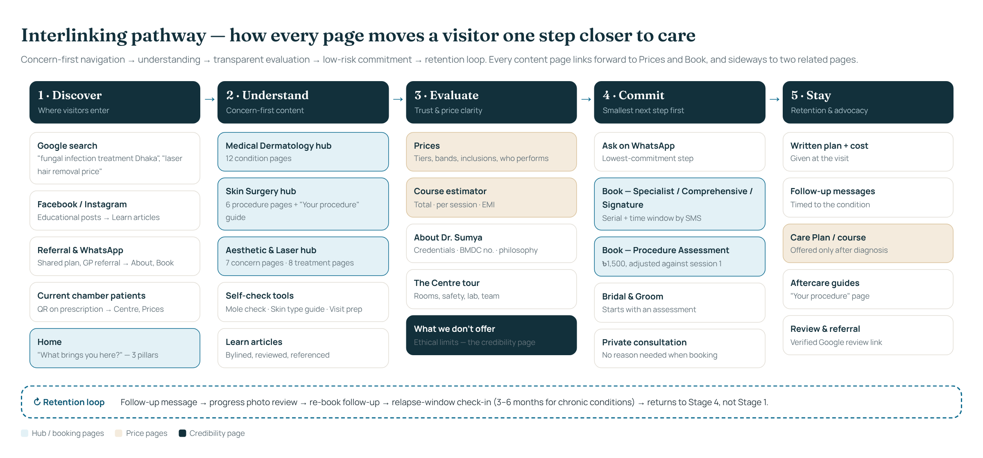
Figure 1. The five-stage pathway. Every content page links forward (Prices, Book) and sideways (two related pages).

3.1 Navigation
Element | Content
Utility bar | [CENTRE NAME] · Ring Road, Mohammadpur · Opening 2027 | Call [PHONE] · WhatsApp · BMDC Reg. A-59492
Main menu | Conditions ▾ · Skin Surgery ▾ · Aesthetic & Laser ▾ · Prices · The Centre · About · [Book a consultation]
Conditions mega-menu | Column 1 Common: Acne · Eczema · Psoriasis · Fungal infection · Hives & allergy | Column 2 Pigment & hair: Melasma · Vitiligo · Hair loss | Column 3 Growths & screening: Mole check (tool) · Skin cancer · Precancerous lesions · Seborrhoeic keratosis & DPN | Footer link: Confidential sexual health
Skin Surgery mega-menu | Skin biopsy · Mole & cyst removal · Skin tags & DPN removal · Wart freezing · Keloid & scar injections · Skin cancer treatment & referral | Feature card: “Before and after your procedure”
Aesthetic & Laser mega-menu | By concern: Acne scars · Pigmentation & sun damage · Unwanted hair · Ageing skin · Hair thinning · Redness | By treatment: Medical facial · Chemical peels · Microneedling · PRP · Laser hair removal · Pigment laser | Feature card: Bridal & Groom programmes
Mobile sticky bar | Three equal buttons at the bottom of every page: Call · WhatsApp · Book
Footer | Care (pillars, Prices) · Visit (The Centre, current chambers, Book, Prepare for your visit) · Trust (What we don’t offer, Photo & consent policy, Privacy, Terms, Medical disclaimer) · Credentials line · “Prices reviewed [DATE]”

3.2 Page tree
Slugs follow the Developer Change Request v1.0 (/conditions/, /treatments/). Three pillar hubs and an aesthetic /concerns/ layer are added on top so that patients can browse by problem.
URL | Page | Links to (min.)
/ | Home | 3 hubs, Prices, Book
/about | About Dr. Sumya Pervin | Centre, What we don’t offer, Book
/the-centre | Inside the Centre + Our team | Prices, Book, Treatments
/chambers | Current hospital chambers & serial numbers | Book, Prepare
/prices | Prices (master list with tabs + estimator) | Book, every treatment page
/what-we-do-not-offer | Our ethical limits | About, Prices
/book · /consultation-prep | Booking · Prepare for your visit tool | Prices, Chambers
/medical-dermatology | Hub | All condition pages
/conditions/acne · eczema · psoriasis · fungal-infection · melasma · hair-loss · urticaria-allergy · vitiligo · seborrhoeic-keratosis-dpn · precancerous-skin-lesions · skin-cancer · sexual-health | 12 condition pages | 2 related conditions, 1–3 treatments, Prices, Book
/tools/mole-check · /skin-type-guide | Self-check tools | Skin cancer, Book
/skin-surgery | Hub | All procedure pages
/treatments/skin-biopsy · cryotherapy · excision-surgery · electrosurgery · intralesional-injection · skin-cancer-treatment | 6 procedure pages | Your procedure, Prices, Book
/your-procedure | Before & after your procedure (pre-op, aftercare, complications, resources) | All procedure pages
/aesthetic-and-laser | Hub (by concern / by treatment) | Concerns, Treatments, Bridal
/concerns/acne-scars · wrinkles-ageing-skin · sun-damage-pigmentation · unwanted-hair · redness-visible-vessels · hair-thinning · body-contouring | 7 concern pages | 2–3 treatments, Prices
/treatments/medical-facial · chemical-peel · microneedling · prp-therapy · laser-hair-removal · pigment-laser · fractional-co2-laser · light-therapy | 8 treatment pages | Concerns, Prices, Estimator, Book
/bridal-and-groom | Bridal & Groom programmes | Prices, Book
/skin-care-products | Dermocosmetic corner | Skin type guide
/learn · /learn/[slug] | Articles hub and articles | Matching condition page
/community · /faq · /contact | Community, FAQ, Contact | Book
/photo-consent-policy · /privacy · /terms · /medical-disclaimer | Legal and governance | —

3.3 Seven patient pathways
Pathway | Page sequence | Conversion and loop
1. Symptom first | Search “ringworm not going away” → /conditions/fungal-infection → “How we diagnose” (same-visit fungal test) → /the-centre#lab → /prices#tests | Book Specialist Consultation → written plan → day-14 check-in → Care Plan offered only if the condition is chronic
2. Treatment shopper | Search “laser hair removal price Dhaka” → /treatments/laser-hair-removal → band table → /prices#estimator | Book Procedure Assessment (৳1,500, adjusted) → patch test → course or pay per session
3. Worried about a mole | Facebook post → /tools/mole-check → /conditions/skin-cancer → /treatments/skin-biopsy | Priority Specialist slot → biopsy → result review (৳0) → treatment or referral pathway
4. Chronic retention | /conditions/psoriasis → “Treatment options” → /treatments/light-therapy → /prices#care-plans | Comprehensive Assessment → Core or Complete Care Plan → relapse-window check-in at 3–6 months
5. Event-driven | Instagram → /bridal-and-groom → /prices#bridal → FAQ “How early should I start?” | Comprehensive Assessment (fee credited) → programme → week-of-event check → review request
6. Confidential | Search at night → /conditions/sexual-health → “Book without giving a reason” | Private consultation slot → discreet invoice wording → partner-care advice
7. Returning patient | WhatsApp follow-up → /your-procedure aftercare or condition page → /book?type=follow-up | Follow-up booked → verified review link → referral card for family

3.4 Linking rulebook
Page type | Must link to | Anchor-text pattern
Condition page | 2 related conditions · 1–3 treatment pages · /prices (exact tab) · /book · /consultation-prep · 1 Learn article | “See consultation fees”, “How fungal tests work”, never “click here”
Concern page (aesthetic) | 2–3 treatment pages ranked by suitability for brown skin · /prices#[treatment] · estimator | “Compare acne-scar treatments”
Treatment page | The concerns it treats · /your-procedure · /prices#[tab] · Book Procedure Assessment · The Centre room | “Laser hair removal prices by area”
Prices page | Every treatment page from its row · Book · What we don’t offer | Row name links to the treatment page
Learn article | One condition page (primary) · one tool · Book | “Read the full melasma guide”
Tool page | The condition page it relates to · Book · Chambers | “Book a mole check”
Every page | Breadcrumb · footer trust links · sticky Call/WhatsApp/Book on mobile | —

3.5 The commitment ladder

Step | Micro-commitment | Where it appears
1 | Read a page; use a free tool | Mole check, Skin type guide, Prepare-for-your-visit (no sign-up required)
2 | Ask one question on WhatsApp | Every page: “Ask on WhatsApp”; staff reply within 2 working hours
3 | Book a consultation (৳2,000) or Procedure Assessment (৳1,500, adjusted) | Hero, end of every page, sticky mobile bar
4 | Accept a written plan and pay per session | In clinic. The default is always pay-as-you-go
5 | Choose a course or Care Plan for its savings | Only after diagnosis; refundable; price-locked 12 months
6 | Leave a verified review; refer family | WhatsApp message 3 days after a good outcome

Part 4 — Behavioural design and choice architecture
The site uses well-established findings from behavioral economics to make good choices easier. It never pushes bigger spending. The test for every nudge: would we be comfortable if the patient saw exactly why it is there? If not, it is not used.

4.1 Principles built into pages and prices
Principle | How it shows up | Example on the site | Ethical guardrail
All-in pricing (avoids “drip pricing”) | One price includes numbing cream, consumables, dressings and aftercare. | “Nothing hidden: consumables are inside the price.” | Lab tests are the only pass-through, at cost, with the receipt shown.
Good–Better–Best (compromise effect) | Three consultation depths; three bridal tiers; two Care Plans. | Comprehensive Assessment sits in the middle as “Best for long-standing concerns”. | “Recommended” labels are clinical guidance, never sales; the doctor may advise the cheaper option.
Honest anchoring | The real pay-as-you-go total sits next to the course or plan price. | “৳6,500 · Pay-as-you-go ৳8,400 · You keep ৳1,900” | Anchors are real single prices. No struck-through fake “was” prices.
Bonus framing | Courses framed as a free extra session rather than a % discount. | “6 sessions for the price of 5.” | Unused sessions refunded at the per-session price.
Risk reversal (loss aversion) | Refunds, price lock, fee credits, free complication review. | “Procedure Assessment ৳1,500 — fully adjusted against session 1.” | Refund rules are written in full on /terms.
Zero-price effect | Items that cost nothing are shown as ৳0, not hidden. | “Report review within 14 days — ৳0.” | Only genuinely free items.
Mental accounting & payment pain | 0% EMI shown monthly, total always beside it. | “৳4,167 / month · total stays ৳25,000.” | EMI never shown without the total; offered only for courses ≥ ৳15,000.
Visible effort / operator disclosure | Doctor minutes and “who performs” on every price. | Dr · Dr+N · N badges. | Badges must match the real roster; audited monthly.
Authority | Credentials, BMDC number, bylines, references. | Credential card under the hero. | Only verifiable qualifications. No “masterclass” padding.
Costly signalling | Publicly refusing lucrative but unscientific treatments. | “Not available here — at any price.” | The list must be honoured in practice.
Ambiguity aversion | Process, timelines, session counts and downtime spelled out. | 5-step consultation; “6–8 sessions, 4–6 weeks apart”. | Ranges, not promises.
Choice-overload control | Browse by concern first; at most 3–4 options per decision. | “What brings you here?” → 3 pillars. | No more than 4 tiers on any table.
Defaults | Reminders on by default; pay-per-session is the default payment. | Booking form: “Send me reminders” pre-ticked (can untick). | Default never adds cost.
Present bias → implementation intentions | Turn advice into a scheduled action. | “Pick a day. We’ll send your serial and what to bring.” Reminders tied to the prescription. | Patient can stop messages with one reply.
Peak-end rule | End every visit on a high: written plan, cost summary, check-in date. | Footer of the plan: “We will message you on [date].” | Promises made are kept (tracked on dashboard).
Endowment | Patient owns a plan and a photo timeline. | “Progress photo timeline you keep.” | Photos only with consent; patient can delete.
Reciprocity | Free tools, guides, community screening hour. | Mole check; printable aftercare sheets. | No email wall on tools.
Social proof | Verified Google reviews; real counts after 6 months. | “Rated [x]/5 from [n] Google reviews” (live widget). | No paid, invented or selectively edited reviews.
Fresh-start timing | Seasonal reminders at natural new starts. | Pre-wedding season (Sept), pre-monsoon fungal advice (May), New Year sun-care. | Educational first; no fake deadlines.

4.2 Built for Bangladesh
Local reality | Design response
Decisions are made with family | “Share this plan with family” WhatsApp button on plans and price estimates; companions welcome in consultations.
Women prefer a female doctor and female staff | Stated plainly: “Female patients are treated by female staff. A chaperone is always available.”
Serial culture and unpredictable waits | Serial and time window by SMS; live queue screen; “If we run 45+ minutes late, we message you.”
Report review is expected to be free | Report review within 14 days ৳0. This matches local norms, and the published price list makes it visible.
Cash and mobile money are everyday | Cash, card, bKash, Nagad accepted; 0% EMI on partner bank cards for larger courses.
WhatsApp is the main channel | WhatsApp on every page; replies within 2 working hours; reminders and check-ins by WhatsApp or SMS.
Colourism in the beauty market | No “fairness” language; imagery shows a range of brown skin tones; whitening treatments are publicly refused.
Modesty in imagery | No revealing body images; procedures illustrated with hands, face crops or diagrams.
Wedding season drives aesthetic demand | Doctor-planned Bridal & Groom programmes with fixed prices and start-by dates.
Monsoon heat drives fungal infections | Seasonal content calendar: fungal prevention guide published every May.
Landmark-based directions | Contact page gives landmarks, parking, and rickshaw/CNG drop-off point.
Language | Website copy is English only (as instructed). Clinic staff consult in Bangla and English. State “Consultations in Bangla and English”.
Number format | Taka sign before the number and lakh grouping for large figures: ৳1,75,000.

4.3 Tactics we never use
- Countdown timers, “only 2 slots left” or any false scarcity.
- “Starting from” prices, or struck-through “was” prices that were never charged.
- Before/after photos without signed consent, without identical lighting, or edited in any way.
- Invented, paid, incentivised or cherry-picked testimonials. The review section stays empty until real reviews exist.
- Guaranteed or permanent results; “No. 1”, “best”, or comparisons with named clinics.
- Selling packages at the first visit; sales commissions for front-office staff (Risk R11 in the tracker).
- Advertising any service before its licence gate is passed.
- Influencer posts making medical claims.

Part 5 — Page-by-page copy
Copy below is ready to paste. Each line carries its role: H1/H2 (headings), Body (paragraph), CTA (buttons). Meta tables give the URL, title tag (≤ 60 characters), meta description (≤ 155 characters), status tag, primary call to action and required links. Every clinical page ends with this byline:
Byline: Written and reviewed by Dr. Sumya Pervin, FCPS (Skin & VD), BMDC A-59492 · Last reviewed [DATE] · References: 2–4 guideline sources (e.g. BAD, AAD, NICE, EADV) listed at the foot of the page.

5.1 Home
URL | /
Title tag | Dermatologist in Dhaka | Dr. Sumya Pervin, FCPS (Skin & VD)
Meta description | Specialist dermatology in Dhaka, diagnosis first. Published prices, written plans, doctor-led procedures. Dr. Sumya Pervin, FCPS, BMDC A-59492.
Status | NOW (Centre blocks switch on by gate)
Primary CTA | Book a consultation
Links out | 3 pillar hubs · Prices · The Centre · What we don’t offer · Learn

Eyebrow Specialist dermatology · FCPS (Skin & VD)
H1 Every treatment starts with a diagnosis.
Body Doctor-led care for skin, hair and nail conditions, plus evidence-based aesthetic and laser treatment. Published prices. A written plan at every visit. Follow-up we actually send.
CTA Book a consultation → | See prices
Body Not sure what you need? See what your first visit will involve (2-minute check).
Body Credential card: Dr. Sumya Pervin · Consultant Dermatologist — Skin, Hair, Nail, Allergy & Venereal Diseases · MBBS · DDV (BSMMU) · FCPS (Skin & VD) · BMDC A-59492
H2 Four promises (strip under hero)
Prices published | See exactly what each fee includes, before you call.
Doctor-led, always disclosed | Every price shows who performs it: Dr. Sumya, or a trained nurse working to her protocol.
Written plan, every visit | Diagnosis, treatment, timeline and total cost, in writing.
Follow-up we send | A check-in message at the right time for your condition.

H2 What brings you here?
Body Medical Dermatology — Skin, hair & nail conditions. Diagnosed properly, treated with evidence, followed up until controlled. [Acne] [Eczema] [Psoriasis] [Fungal infection] [Hair fall] [Melasma] [Hives] [Vitiligo]
Body Skin Surgery & Procedures — Moles, lumps & growths. Minor skin surgery in a clean procedure room, with lab confirmation when needed. [Mole check] [Mole / cyst removal] [Skin tags & DPN] [Warts] [Keloid] [Skin biopsy]
Body Aesthetic & Laser — Look like yourself, rested. Only what the evidence supports for South Asian skin, planned by a dermatologist. [Acne scars] [Pigmentation] [Unwanted hair] [Ageing skin] [Hair thinning] [Bridal prep]
H2 From first visit to a plan you can follow
Body 1 History: bring your creams and old prescriptions. 2 Examination: a proper look, with dermoscopy where it helps. 3 Tests, only if useful: explained and priced before anything is done. 4 Written plan: diagnosis, options, timeline and total cost. 5 Follow-up: we message you to check progress.
H2 Choose the depth of your first visit
Body Three cards: Specialist Consultation ৳2,000 · Comprehensive Assessment ৳3,500 (Best for long-standing concerns) · Signature Skin & Hair Review ৳6,000. Inclusions as in the price list. Line below: “Follow-up within 30 days ৳1,200 · No package is sold at a first visit · Hospital-chamber fees follow each hospital’s tariff.”
H2 Built like a clinic, not a salon
Body Consultation suites · Laser suite · In-house lab, each with one honest sentence (see The Centre). Link: Take the tour →
H2 Some treatments are not available here, at any price.
Body Saying no is part of good medicine. Six tiles: Skin-whitening drips & injections · Steroid creams without a diagnosis · “Instant fairness” packages · Treatment from a photo alone · Unregistered injectables · Guaranteed results. Link: Read the full list →
H2 Written and reviewed by Dr. Sumya
Body Three latest articles with category, title, reading time and byline.
H2 Pick a day. We’ll send your serial, time window and what to bring.
CTA Book a consultation | Ask on WhatsApp

5.2 About Dr. Sumya Pervin
URL | /about
Title tag | Dr. Sumya Pervin — Dermatologist, FCPS (Skin & VD), Dhaka
Meta description | Dr. Sumya Pervin, FCPS (Skin & VD), DDV (BSMMU). Consultant dermatologist in Dhaka. BMDC Reg. A-59492. Diagnosis-first, evidence-based care.
Status | NOW
Primary CTA | Book a consultation
Links out | The Centre · What we don’t offer · Prices · Chambers

H1 Dr. Sumya Pervin
Body Consultant Dermatologist — Skin, Hair, Nail, Allergy & Venereal Diseases. MBBS (Sir Salimullah Medical College, 2011) · DDV, Diploma in Dermatology & Venereology (BSMMU, 2019) · FCPS, Skin & VD (Bangladesh College of Physicians and Surgeons, 2025) · Trained in dermatosurgery · BMDC Registration No. A-59492.
H2 Fifteen years in medicine. Seven as a skin specialist.
Body Dr. Sumya Pervin qualified from Sir Salimullah Medical College in 2011 and spent the following decade in public health service across district and tertiary hospitals, including a period in rural practice that still shapes how she listens to patients. She trained in dermatology at BSMMU, completing her DDV in 2019, and served in the Department of Skin & VD at Sir Salimullah Medical College & Mitford Hospital. In 2025 she was awarded the FCPS in Skin & VD, the country’s highest specialist qualification in the field.
H2 How she practises
Body Her position is simple, and in today’s Dhaka market unusual: a skin condition should be diagnosed before it is treated, and the patient should understand both. She will not prescribe from a photograph. She will ask to see what you are already applying, because many long-standing “unresponsive” rashes in Bangladesh are caused or kept going by over-the-counter steroid creams. She will tell you when a condition is chronic rather than curable. And she will not offer a treatment she cannot justify from evidence. Skin-lightening infusions, unregistered injectables and “instant fairness” programmes are not available at any price.
H2 Areas of practice
Body General dermatology (skin, hair, nails) · Acne and acne scarring · Pigmentation and melasma · Eczema, psoriasis and chronic inflammatory skin disease · Hives and skin allergy · Fungal and bacterial infections · Children’s skin · Hair loss · Dermatosurgery and minor procedures · Skin cancer screening · Sexual health and STIs (confidential) · Evidence-based aesthetic and laser dermatology.
H2 Building a practice that outlasts one doctor
Body The Centre on Ring Road, Mohammadpur, is designed so every patient gets the same standard: the same consultation steps, written plans, consent rules and follow-up, whoever is on duty. Every doctor who joins is credentialed against these standards.
Body Consultations in Bangla and English.
CTA Book with Dr. Sumya | See where she consults now

5.3 The Centre — tour and team
URL | /the-centre
Title tag | Inside the Centre | Dermatology Centre, Ring Road, Mohammadpur
Meta description | Tour Dr. Sumya Pervin’s dermatology centre: consultation suites, laser suite, procedure room, in-house lab and phototherapy. Opening 2027.
Status | OPENING
Primary CTA | Book a consultation
Links out | Prices · Laser hair removal · Skin surgery · Phototherapy

H1 Built like a clinic, not a salon.
Body Every room has a clinical reason to exist. Here is what you will see, and why it matters to your care.
Room | Copy (≤ 40 words each)
Reception | The full price list is on the wall, not in a drawer. Pay by cash, card, bKash or Nagad. Our front-office team is not paid sales commission, so nobody here has a reason to upsell you.
Waiting lounge | A live screen shows your serial and the expected wait. Water and tea are on us. Short skin-health videos replace television noise. A family corner keeps companions comfortable.
Consultation suites | Private, quiet rooms with dermoscopy and magnified lighting. Your first visit runs 20–60 minutes depending on the depth you choose. You leave with a written plan.
In-house lab | Fungal microscopy (KOH) gives an answer while you wait, so treatment starts on a confirmed diagnosis. PRP is prepared in a closed, sterile system in front of you.
Clinical photography studio | Fixed lighting and background, so progress photos are honest comparisons. Photos are taken only with your signed consent and kept in your medical record.
Procedure room | Autoclave-sterilised instruments, single-use consumables and a sterile field for biopsies, mole and cyst removal, and injections.
Medical aesthetics room | Facials and peels performed by trained nurses following Dr. Sumya’s written protocols, with the doctor on site.
Laser suite | Interlocked door, warning light, eye protection for everyone in the room and smoke-plume extraction. Settings are chosen for brown skin and recorded every session.
Phototherapy cabin (Year 2) | Narrowband UVB for psoriasis, vitiligo and eczema. Doses are measured and logged.

H2 Our team
Body Cards for each team member: photo, name, role and registration (e.g. “Registered Nurse · BNMC [no.]”). Roles at opening: Medical Director, registered nurse, dermatology assistant, two front-office executives. Laser nurse and visiting consultants join at full launch.
H2 Getting here
Body [ADDRESS], Ring Road / Tajmahal Road corridor, Mohammadpur. Landmark: [LANDMARK]. Parking: [details]. Rickshaw and CNG drop-off at the gate.
Behavioural note
Tangible evidence of quality (the “servicescape”) carries premium prices. Name the specific feature (interlock, autoclave, KOH microscope) rather than saying “state-of-the-art”.

5.4 Current chambers (until the Centre opens)
URL | /chambers
Title tag | Chambers & Serial — Dr. Sumya Pervin, Dermatologist, Shyamoli
Meta description | Chamber times and serial numbers for Dr. Sumya Pervin at Alliance Hospital and DCIMCH, Shyamoli, Dhaka.
Status | NOW
Primary CTA | Call for serial
Links out | Prepare for your visit · Book

H1 Where Dr. Sumya consults now
Body Alliance Hospital Ltd, 24/3 Khilji Road (Ring Road), Shyamoli: [days/time, confirm in writing]. DCIMCH, 2/1 Ring Road, Shyamoli: [days/time, confirm in writing], Friday closed. Fees follow each hospital’s tariff. The prices on this website apply to the Centre.
H2 What to bring
Body Every cream, ointment, oil or soap you use (bring the tubes, not the names) · previous prescriptions and reports · a list of other medicines · for hair problems, come without oil · for nails, come without polish · photos of the problem at its worst if it comes and goes.

5.5 Medical Dermatology hub
URL | /medical-dermatology
Title tag | Skin, Hair & Nail Conditions Treated | Dermatologist Dhaka
Meta description | Diagnosis-first treatment for acne, eczema, psoriasis, fungal infection, melasma, hair loss, hives, vitiligo and skin cancer screening in Dhaka.
Status | NOW
Primary CTA | Book a Specialist Consultation
Links out | All 12 condition pages · Care Plans · Mole check

H1 Skin, hair and nail conditions
Body Most skin conditions are common, treatable and badly served by guesswork. Here you get a diagnosis first, an explanation you understand, and a plan that is checked over time, not just one prescription.
H2 Conditions
Body Grid of 12 cards. Each card has: the name, one plain-language line, “Chronic: Care Plan available” where relevant, and a link.
H2 Conditions that last months deserve a plan that lasts months
Body For eczema, psoriasis, acne, hives and vitiligo, a 6-month Care Plan bundles your follow-ups and photo reviews for less than paying visit by visit. It is offered only after diagnosis. See Care Plans →

5.6 Acne
URL | /conditions/acne
Title tag | Acne Treatment in Dhaka | FCPS Dermatologist
Meta description | Acne treatment that starts with the right diagnosis: creams, tablets and procedures planned by an FCPS dermatologist. Clear timelines and fees.
Status | NOW
Primary CTA | Book a Specialist Consultation (৳2,000)
Links out | Acne scars · Hormones/PCOS article · Chemical peel · Care Plans

H1 Acne treatment in Dhaka — a plan, not a cream of the month
Body Acne is a long-term condition of the oil glands and hair follicles. It is very treatable, but most treatments take 8–12 weeks to show their full effect. Most of our work is choosing the right combination for your skin and keeping you on it long enough for it to work.
H2 What it is
Body Blocked pores (blackheads, whiteheads), inflamed spots and, in more severe acne, deep painful lumps that can leave marks and scars. Hormones, genetics, some cosmetics and some medicines all play a part.
H2 What makes it worse
- Heavy, oily make-up and hair oils on the forehead
- Picking and squeezing (the main cause of dark marks)
- Steroid creams and “mixed” creams from the pharmacy
- Some gym supplements and anabolic steroids
- Stopping treatment as soon as it starts working

H2 How we diagnose it
Body We grade your acne, check for scarring and dark marks, and ask about periods, hair growth and medicines. Hormone tests are ordered only if there are signs of a hormonal cause (such as polycystic ovary syndrome).
H2 Treatment options
- Creams and gels: retinoids, benzoyl peroxide, azelaic acid. These are the foundation for almost everyone.
- Tablets: antibiotics for a limited course, always combined with a cream to prevent resistance. Hormonal treatment for suitable women.
- Isotretinoin for severe or scarring acne, with blood monitoring and strict pregnancy prevention.
- In-clinic help: extraction, chemical peels, steroid injection for painful cysts.
- Afterwards: treating marks and scars once the acne is controlled (see Acne scars).

H2 What will not work
- Toothpaste, lemon, or “anti-acne” face packs
- Antibiotic tablets alone, or repeated without a review
- Steroid creams, which can cause a stubborn rash that looks like acne
- Facials as the main treatment for active acne

H2 When to see a doctor quickly
Body Painful nodules, sudden severe acne, acne with fever or joint pain, or low mood linked to your skin.
H2 What it typically costs here
Body Specialist Consultation ৳2,000 · follow-up ৳1,200 · Core Care Plan ৳6,500 for 6 months · acne extraction ৳2,500 · targeted peel ৳7,000 (from licence).
H2 Questions patients ask
Will my acne come back? It can. A maintenance cream after clearing reduces the chance considerably.
How soon will I see a change? Usually some improvement by week 6 and a clear difference by week 12.
Is isotretinoin safe? In the right patient, with monitoring, it is one of the most effective medicines in dermatology. We explain every risk before prescribing.
CTA Book a consultation · See fees · Ask on WhatsApp
Why this page converts
Sets the timeline expectation (8–12 weeks) up front. This reduces the early drop-off that comes from present bias, and leads naturally to the Care Plan.

5.7 Eczema
URL | /conditions/eczema
Title tag | Eczema Treatment in Dhaka | Dermatologist
Meta description | Eczema and dermatitis treatment in Dhaka: trigger hunting, the right steroid at the right strength, and a long-term plan. FCPS dermatologist.
Status | NOW
Primary CTA | Book a Specialist Consultation (৳2,000)
Links out | Hives & allergy · Patch test · Phototherapy · Care Plans

H1 Eczema — calm the itch, then keep it calm
Body Eczema (dermatitis) is an itchy, inflamed skin condition that comes and goes. It can’t be cured once and for all, but it can usually be controlled well, and most flare-ups can be prevented.
H2 What it is
Body Dry, itchy, red or darkened patches, often in skin folds, on hands or on the face. Types include atopic eczema (often since childhood), contact dermatitis (from something touching the skin) and hand eczema.
H2 What makes it worse
- Hot showers, harsh soaps and detergents
- Sweat and synthetic fabrics in Dhaka’s humidity
- Stopping moisturiser once the skin looks better
- Strong steroid creams used without guidance

H2 How we diagnose it
Body A careful history and examination. Where an allergy to something touching the skin is suspected, we may recommend a patch test, which takes three visits in one week.
H2 Treatment options
- Daily emollients and soap substitutes, which is the foundation
- Topical steroids of the right strength, for the right number of days, with a written plan for stepping down
- Steroid-free creams (calcineurin inhibitors) for the face and folds
- Phototherapy (NB-UVB) for widespread eczema (Year 2)
- Tablets or injections for severe eczema, with blood monitoring where required

H2 What will not work
- Switching cream every week
- Herbal or “cooling” oils with fragrance
- Antibiotic–steroid–antifungal “mixed” creams

H2 When to see a doctor quickly
Body Weeping, crusted or painful eczema (possible infection), sudden spread with fever, or eczema around the eyes.
H2 What it typically costs here
Body Comprehensive Assessment ৳3,500 recommended for long-standing eczema · patch test ৳6,500 · Core Care Plan ৳6,500 / Complete ৳12,500.
CTA Book a consultation · See fees · Ask on WhatsApp
Why this page converts
“Can’t be cured, can be controlled” is a loss-framed honesty statement. It builds credibility and justifies a Care Plan without any pressure.

5.8 Psoriasis
URL | /conditions/psoriasis
Title tag | Psoriasis Treatment in Dhaka | FCPS Skin Specialist
Meta description | Psoriasis treatment in Dhaka: creams, phototherapy and systemic medicines with proper monitoring. Long-term plans by an FCPS dermatologist.
Status | NOW
Primary CTA | Book a Specialist Consultation (৳2,000)
Links out | Eczema · Phototherapy · Care Plans · Joint-pain article

H1 Psoriasis — long-term control, properly monitored
Body Psoriasis is a long-term immune condition that speeds up skin turnover, causing thick, scaly patches. It is not contagious. With the right plan, most people get their skin clear or nearly clear.
H2 What it is
Body Well-defined red or dark, scaly plaques, often on elbows, knees, scalp and lower back. Nails and joints can be affected. Psoriasis is also linked with heart and metabolic health, so we look at the whole person.
H2 How we diagnose it
Body Clinical examination, a severity score, and questions about joint pain. Before tablets we arrange blood tests, and for some treatments a chest X-ray.
H2 Treatment options
- Creams: steroid plus vitamin D combinations, scalp treatments
- Phototherapy (NB-UVB), two to three sessions a week (Year 2)
- Tablets: methotrexate, acitretin or ciclosporin, with monitoring
- Biologic injections for severe psoriasis, where suitable and affordable

H2 What will not work
- Long-term strong steroid creams on large areas
- Oral steroid tablets (these can trigger severe flares)
- “Permanent cure” treatments

H2 When to see a doctor quickly
Body Rapidly spreading redness over most of the body, pustules with fever, or swollen painful joints.
H2 What it typically costs here
Body Comprehensive Assessment ৳3,500 · follow-up ৳1,200 · NB-UVB ৳800 per session or 12 for ৳8,800 (Year 2) · Care Plans from ৳6,500.
CTA Book a consultation · See fees · Ask on WhatsApp

5.9 Fungal infection (ringworm, tinea)
URL | /conditions/fungal-infection
Title tag | Fungal Infection (Ringworm) Treatment in Dhaka
Meta description | Stubborn ringworm in Dhaka? Same-visit fungal test, the right medicine for the right duration, and no steroid mixes. FCPS dermatologist.
Status | NOW
Primary CTA | Book a Specialist Consultation (৳2,000)
Links out | Eczema · The Centre lab · Prices: tests · Article: why ringworm comes back

H1 Ringworm that keeps coming back? Let’s confirm it first.
Body Fungal skin infections (tinea, ringworm) have become harder to treat across South Asia. A big reason is cream that contains a steroid, which hides the infection while letting it spread. We confirm the diagnosis with a quick test, then treat it properly.
H2 What it is
Body Itchy, ring-shaped or spreading patches in the groin, waist, under the breasts, buttocks, or on the body, feet and nails. It spreads within families and through shared towels and clothes.
H2 What makes it worse
- Steroid or “mixed” creams
- Tight, damp clothing in hot weather
- Stopping treatment when the itch settles
- Untreated family members

H2 How we diagnose it
Body A scraping looked at under our microscope (KOH test), with results in the same visit, from the licence stage onwards. Sometimes a culture is sent to a partner lab.
H2 Treatment options
- Antifungal creams for limited infections, used two weeks beyond clearing
- Antifungal tablets for widespread or recurrent infection, at the right dose and duration
- Household plan: treating close contacts, laundry at high temperature, separate towels
- Nails need months of treatment; we explain realistic outcomes

H2 What will not work
- Any cream with a steroid in it
- Stopping when the itch stops
- Treating yourself but not your family

H2 When to see a doctor quickly
Body Painful, pus-filled patches on the scalp (especially in children), or infection in people with diabetes or low immunity.
H2 What it typically costs here
Body Specialist Consultation ৳2,000 · KOH microscopy ৳500 (included in the Signature Review) · follow-up ৳1,200.
CTA Book a consultation · See fees · Ask on WhatsApp
Why this page converts
Positions the in-house test as the visible proof of “diagnosis first”, and blames the cream rather than the patient, which avoids shame.

5.10 Melasma and pigmentation
URL | /conditions/melasma
Title tag | Melasma Treatment in Dhaka | Pigmentation Specialist
Meta description | Honest melasma treatment in Dhaka: sun protection, proven creams, peels and lasers as add-ons, plus maintenance. Manageable, not curable.
Status | NOW
Primary CTA | Book a Specialist Consultation (৳2,000)
Links out | Sun damage · Chemical peel · Pigment laser · Skin type guide

H1 Melasma — manageable, not curable. Here’s what actually works.
Body Melasma causes brown or grey-brown patches on the cheeks, forehead, upper lip and nose. It is triggered by sunlight, visible light, heat and hormones. Anyone promising to remove it forever is not telling you the truth. With the right plan, most patients see clear lightening within 3 months.
H2 What it is
Body A long-term pigment condition, commonest in women aged 25–50 and very common in South Asian skin. It is different from freckles, sun spots and the dark marks left by acne. Those need different treatment.
H2 What makes it worse
- Sun and visible light (including through windows)
- Heat: kitchens, saunas, hot yoga
- Hormonal pills, pregnancy
- Harsh scrubs and unprescribed bleaching creams

H2 How we diagnose it
Body Examination under Wood’s lamp and dermoscopy to tell melasma from other pigment problems and judge how deep it is.
H2 Treatment options
- Daily tinted, broad-spectrum sunscreen (iron oxides block visible light), the single most important step
- Prescription creams: short supervised courses of combination cream, then maintenance with azelaic acid and similar
- Tranexamic acid tablets for suitable patients, after screening for clot risk
- Chemical peels as a booster
- Laser toning only as an add-on to the plan, never on its own, because melasma can rebound

H2 What will not work
- Bleaching or “whitening” creams bought without a prescription
- Glutathione drips
- Aggressive lasers as the first treatment

H2 When to see a doctor quickly
Body A single dark spot that is changing, bleeding, or looks different from the rest (see Mole check).
H2 What it typically costs here
Body Comprehensive Assessment ৳3,500 (includes baseline photos for honest comparison) · targeted peel ৳7,000 · full-face laser toning ৳9,000 (laser stage).
CTA Book a consultation · See fees · Ask on WhatsApp
Why this page converts
The headline uses expectation-setting framing. Patients who expect “control” stay on treatment longer than patients promised a “cure”.

5.11 Hair loss
URL | /conditions/hair-loss
Title tag | Hair Fall & Hair Loss Treatment in Dhaka
Meta description | Hair fall in Dhaka diagnosed properly: trichoscopy, targeted blood tests and proven treatment including minoxidil and PRP. FCPS dermatologist.
Status | NOW
Primary CTA | Book a Specialist Consultation (৳2,000)
Links out | Hair thinning (aesthetic) · PRP therapy · Intralesional injection · Signature Review

H1 Hair fall — find the type first, then treat it
Body Hair loss has many causes, and each is treated differently. A scalp examination with trichoscopy, plus a few targeted blood tests, usually tells us which type you have and what will help.
H2 What it is
Body Common types: pattern hair loss (men and women), shedding after illness, stress or childbirth (telogen effluvium), patchy loss (alopecia areata), and scalp disease such as dandruff or fungal infection.
H2 How we diagnose it
Body Trichoscopy (a magnified look at the scalp), a pull test, and blood tests when they change treatment (for example iron, thyroid, vitamin D).
H2 Treatment options
- Minoxidil (topical, or low-dose tablets for suitable patients)
- Finasteride for suitable men
- PRP therapy as an add-on for pattern hair loss
- Steroid injections for alopecia areata
- Treating the trigger, such as low iron, thyroid problems or scalp inflammation

H2 What will not work
- Hair oils marketed as “regrowth” treatments
- Supplements without a proven deficiency
- PRP for shedding that will settle on its own

H2 When to see a doctor quickly
Body Rapid patchy loss, a painful or scarring scalp, or hair loss with other symptoms like weight change.
H2 What it typically costs here
Body Signature Skin & Hair Review ৳6,000 (includes trichoscopy) or Specialist ৳2,000 + trichoscopy ৳1,500 · PRP ৳9,000 per session, 3 sessions ৳24,000.
CTA Book a consultation · See fees · Ask on WhatsApp

5.12 Hives and skin allergy (urticaria)
URL | /conditions/urticaria-allergy
Title tag | Hives & Skin Allergy Treatment in Dhaka
Meta description | Hives (urticaria) and skin allergy treatment in Dhaka. Most chronic hives are not caused by food. The right antihistamine plan, explained.
Status | NOW
Primary CTA | Book a Specialist Consultation (৳2,000)
Links out | Eczema · Patch test · FAQ

H1 Hives that won’t go away
Body Hives (urticaria) are itchy, raised welts that come and go, sometimes with swelling of the lips or eyes. If they last more than six weeks, they are usually not caused by a food allergy. A clear plan controls them in most people.
H2 What it is
Body Short-lived welts that move around the body. Acute hives often follow an infection or medicine. Chronic hives are usually driven by the immune system, not by something you ate.
H2 How we diagnose it
Body A careful history matters more than an allergy panel. Blood tests are limited to what will change treatment.
H2 Treatment options
- Non-drowsy antihistamines taken daily at the correct dose (sometimes higher than the packet says, under supervision)
- Avoid triggers such as some painkillers (NSAIDs)
- Specialist injections for hives that do not respond

H2 What will not work
- Large “allergy panels” that test hundreds of foods
- Repeated steroid injections

H2 When to see a doctor quickly
Body Emergency: swelling of the tongue or throat, difficulty breathing, or feeling faint. Go to the nearest emergency department now.
H2 What it typically costs here
Body Specialist Consultation ৳2,000 · follow-up ৳1,200 · Core Care Plan ৳6,500.
CTA Book a consultation · See fees · Ask on WhatsApp

5.13 Vitiligo
URL | /conditions/vitiligo
Title tag | Vitiligo Treatment in Dhaka | Skin Specialist
Meta description | Vitiligo treatment in Dhaka with respect and evidence: creams, phototherapy and options for stable patches. FCPS dermatologist.
Status | NOW
Primary CTA | Book a Specialist Consultation (৳2,000)
Links out | Phototherapy · Care Plans · Article: vitiligo myths

H1 Vitiligo — treatment, and respect
Body Vitiligo causes white patches where the skin has lost its pigment. It is not contagious, it is not caused by food, and it is nobody’s fault. Treatment can bring colour back in many patients, especially on the face, and can stop it spreading.
H2 What it is
Body An autoimmune condition. It may stay stable for years or spread. Sometimes it occurs with thyroid problems, which we check.
H2 How we diagnose it
Body Wood’s lamp examination to map active areas, photographs to track change, and a thyroid test where indicated.
H2 Treatment options
- Creams: steroid or calcineurin-inhibitor creams
- NB-UVB phototherapy, the most effective treatment for widespread vitiligo (Year 2)
- Short courses of tablets to stop rapid spread
- Surgical grafting for small patches that have been stable for at least a year (referral)

H2 What will not work
- Fish-and-milk food myths
- Unproven herbal pastes on the skin
- Promises of complete repigmentation

H2 When to see a doctor quickly
Body Rapidly spreading new patches: early treatment can slow this.
H2 What it typically costs here
Body Comprehensive Assessment ৳3,500 (includes photo mapping) · NB-UVB card 12 for ৳8,800 (Year 2) · Care Plans from ৳6,500.
CTA Book a consultation · See fees · Ask on WhatsApp

5.14 Seborrhoeic keratosis and DPN
URL | /conditions/seborrhoeic-keratosis-dpn
Title tag | Seborrhoeic Keratosis & DPN Removal Dhaka
Meta description | Small dark bumps on the face (DPN) and seborrhoeic keratoses: harmless, removable. Doctor-performed electrosurgery with banded prices.
Status | NOW
Primary CTA | Book a Specialist Consultation (৳2,000)
Links out | Electrosurgery · Cryotherapy · Mole check

H1 Small dark bumps on the face and neck
Body Dermatosis papulosa nigra (DPN) and seborrhoeic keratoses are harmless growths that become more common with age. Removing them is optional and cosmetic, but it is quick, and done well it leaves little trace.
H2 What it is
Body DPN: small dark, smooth bumps on the cheeks, around the eyes and on the neck, very common in brown skin and often in families. Seborrhoeic keratoses: larger, “stuck-on” waxy spots on the body.
H2 How we diagnose it
Body Dermoscopy confirms they are benign. Anything unusual is biopsied first.
H2 Treatment options
- Electrosurgery / radiofrequency removal, the usual choice for DPN
- Cryotherapy for larger keratoses on the body
- Fine curettage for raised lesions

H2 What will not work
- Home removal with threads, acids or “wart pens”
- Removing a changing spot without checking it first

H2 When to see a doctor quickly
Body If a spot bleeds, grows quickly or looks different from the others, have it checked.
H2 What it typically costs here
Body Electrosurgery by number of lesions: up to 10 ৳3,500 · 11–30 ৳6,000 · 31+ / full face and neck ৳9,000 (from licence).
CTA Book a consultation · See fees · Ask on WhatsApp

5.15 Precancerous skin lesions (actinic and arsenical keratosis)
URL | /conditions/precancerous-skin-lesions
Title tag | Arsenical & Actinic Keratosis | Skin Check Dhaka
Meta description | Hard rough spots on palms and soles may be arsenical keratosis, linked to arsenic in water. Early checking and treatment prevents skin cancer.
Status | NOW
Primary CTA | Book a Specialist Consultation (৳2,000)
Links out | Skin cancer · Skin biopsy · Cryotherapy · Community screening

H1 Rough spots that need a closer look
Body Some rough or scaly patches are early warning signs that can turn into skin cancer if ignored. In Bangladesh, an important cause is long-term arsenic in drinking water. That causes hard, corn-like spots on the palms and soles (arsenical keratosis).
H2 What it is
Body Arsenical keratosis: hard, yellowish, rough bumps on palms and soles, sometimes with spotty dark and light skin on the body. Actinic keratosis: rough, sun-damaged spots on the face and hands, less common in brown skin. Bowen’s disease: a slowly growing scaly patch.
H2 How we diagnose it
Body Examination and dermoscopy, a biopsy if any spot is thick, painful, bleeding or growing, and questions about current and past water sources.
H2 Treatment options
- Cryotherapy or curettage for thin lesions
- Prescription creams for multiple lesions
- Excision for thick or suspicious lesions
- Safe water: we tell you how to get your tube-well tested (local DPHE/upazila arrangements) and why it matters for your family

H2 What will not work
- Cutting or filing them at home
- Ignoring a lesion that becomes an ulcer

H2 When to see a doctor quickly
Body A spot that grows, bleeds, ulcerates or becomes painful.
H2 What it typically costs here
Body Specialist Consultation ৳2,000 · cryotherapy from Band A ৳2,000 · biopsy ৳4,000 + lab at cost.
CTA Book a consultation · See fees · Ask on WhatsApp
Why this page converts
Locally specific authority content (arsenic) is rare among competitors. It builds expert credibility and earns links from public-health pages.

5.16 Skin cancer and mole checks
URL | /conditions/skin-cancer
Title tag | Skin Cancer Screening & Mole Check in Dhaka
Meta description | Mole checks and skin cancer screening in Dhaka, including palms, soles and nails. Biopsy, removal and clear referral pathways.
Status | NOW
Primary CTA | Book a Specialist Consultation (৳2,000)
Links out | Mole check tool · Skin biopsy · Excision · Skin cancer treatment & referral

H1 Mole checks and skin cancer screening
Body Skin cancer is less common in brown skin, but when it happens it is often found late, partly because it appears in places people don’t check: the palms, soles and under the nails. A dermatologist’s check with dermoscopy takes minutes.
H2 What it is
Body Basal cell carcinoma (BCC): a slow-growing, often shiny or pigmented bump that does not heal; in Asian skin it is often dark. Squamous cell carcinoma (SCC): a growing, crusted or ulcerated lump, sometimes on old scars, burns or arsenical keratoses. Melanoma: a changing dark spot. In brown skin the commonest type appears on the soles, palms or as a dark stripe in a nail.
H2 How we diagnose it
Body Full skin check with dermoscopy. The ABCDE rule: Asymmetry, Border, Colour, Diameter, Evolving. Plus our extra rule for brown skin: check palms, soles and nails. A biopsy confirms any suspicion.
H2 Treatment options
- Surgical removal of small, low-risk cancers here (see Excision)
- Referral to surgical oncology, plastic surgery or radiation oncology for larger or high-risk cancers, Mohs surgery or radiation therapy. We help you through it and stay involved in follow-up
- Prevention: sun protection, safe water, and covering and checking old burns and scars

H2 What will not work
- Home “mole removal” creams
- Waiting to see if a changing spot settles

H2 When to see a doctor quickly
Body A new dark stripe in a nail, a dark spot on the sole that is changing, any sore that has not healed in 4 weeks, or a mole that bleeds.
H2 What it typically costs here
Body Specialist Consultation ৳2,000 · digital mole record (up to 5 lesions) ৳2,500 · full-body mole map in the Signature Review ৳6,000 · biopsy ৳4,000 + lab at cost.
CTA Book a consultation · See fees · Ask on WhatsApp

5.17 Confidential sexual health
URL | /conditions/sexual-health
Title tag | Confidential Sexual Health & STI Care | Dhaka
Meta description | Private, non-judgemental sexual health care by a Skin & VD specialist in Dhaka. Book without giving a reason. Discreet billing.
Status | NOW
Primary CTA | Book a private consultation
Links out | Book (private option) · Privacy policy

H1 Confidential sexual health care
Body Dr. Sumya is a specialist in Skin & Venereal Diseases. If you are worried about a sore, a rash, discharge, warts or a possible infection, you can see her privately, without judgement, and without giving a reason when you book.
H2 What it is
Body Common concerns: genital warts, herpes, syphilis, fungal and bacterial infections, itching, and worries after a risk. Many are easily treated. Some need tests and partner care.
H2 How we diagnose it
Body A private examination and the right tests, explained before they are done. Results are shared only with you.
H2 Treatment options
- Treatment of the infection, with a written plan
- Wart treatment by freezing or electrosurgery
- Testing, including referral for HIV and hepatitis testing where needed
- Advice on protecting partners

H2 What will not work
- Buying antibiotics without a diagnosis
- Delaying because of embarrassment. Everything here is confidential.

H2 When to see a doctor quickly
Body Severe pain, fever with genital sores, or symptoms in pregnancy.
H2 What it typically costs here
Body Private consultation ৳2,000 (a private time slot; your invoice reads “Specialist consultation”).
CTA Book a consultation · See fees · Ask on WhatsApp

5.18 Skin Surgery & Procedures hub
URL | /skin-surgery
Title tag | Mole, Cyst & Wart Removal in Dhaka | Skin Surgery
Meta description | Doctor-performed minor skin surgery in Dhaka: biopsies, mole and cyst removal, skin tags, warts and keloids. Banded prices, sterile procedure room.
Status | LICENCE
Primary CTA | Book a consultation
Links out | 6 procedure pages · Your procedure · Prices: Skin Surgery

H1 Skin surgery and procedures
Body Minor skin surgery performed by Dr. Sumya in a sterile procedure room, using local anaesthetic, with the lab report shared and explained. Prices are banded by size or number of lesions, so you know the cost before the day.
H2 Procedures
Body Cards: Skin biopsy · Mole & cyst removal (excision) · Skin tags & DPN (electrosurgery) · Wart & keratosis freezing (cryotherapy) · Keloid, alopecia & cyst injections · Skin cancer treatment & referral.
H2 Every procedure includes
Body Local anaesthetic · sterile single-use consumables · dressing · aftercare sheet · stitch removal where needed · a free complication review within 7 days. The lab fee is passed through at cost, and you see the receipt.

5.19 Skin biopsy
URL | /treatments/skin-biopsy
Title tag | Skin Biopsy in Dhaka | Dermatologist-Performed
Meta description | A skin biopsy confirms a diagnosis. Quick, local anaesthetic, results explained in person. Price ৳4,000 plus lab at cost.
Status | LICENCE
Primary CTA | Book a Specialist Consultation
Links out | Skin cancer · Your procedure · Prices

H1 Skin biopsy — when the answer matters
Body A biopsy takes a small sample of skin so a pathologist can confirm the diagnosis under a microscope. It takes about 15 minutes under local anaesthetic.
H2 At a glance
Used for | Suspicious moles or growths, rashes that do not respond, hair loss with scarring, some nail and mouth lesions
Time | 15–20 minutes
Anaesthetic | Local injection
Results | Usually 5–10 working days; explained at a report-review visit (৳0 within 14 days)
Who performs | Dr. Sumya (Dr)
Price | ৳4,000 + histopathology at the lab’s price (typically ৳2,000–3,500; receipt shown)

H2 How it works
Body Punch biopsy (a small round sample, 1–2 stitches), shave biopsy (no stitches), or incisional biopsy (a wedge from a larger lesion). We tell you which and why before starting.
H2 Before and after
Body Keep the dressing dry for 24 hours, then clean daily. Stitches out in 7–14 days depending on site.
H2 Possible side effects
Body Minor bleeding, infection (uncommon), a small scar. Brown skin can scar darker or form keloids; we plan the site to minimise this.
CTA Book a consultation · See skin-surgery prices · Before and after your procedure

5.20 Cryotherapy (freezing)
URL | /treatments/cryotherapy
Title tag | Wart & Keratosis Freezing in Dhaka | Cryotherapy
Meta description | Liquid-nitrogen cryotherapy for warts and keratoses, banded by number of lesions. Doctor-performed. ৳2,000–5,000.
Status | LICENCE
Primary CTA | Book a Procedure Assessment (৳1,500, adjusted against session 1)
Links out | Warts article · Precancerous lesions · Seborrhoeic keratosis · Prices

H1 Cryotherapy for warts and rough spots
Body Liquid nitrogen freezes the lesion, which then blisters and falls off over 1–2 weeks. Warts usually need 2–4 sessions, 2–3 weeks apart.
H2 At a glance
Used for | Viral warts, seborrhoeic keratoses, thin arsenical/actinic keratoses
Sessions | Warts 2–4; keratoses often 1
Downtime | Blister for a few days; normal activities continue
Who performs | Dr. Sumya (Dr)
Price per session | Band A 1–3 lesions ৳2,000 · Band B 4–10 ৳3,500 · Band C 11+ ৳5,000

H2 How it works
Body Short, controlled freeze cycles with a spray or probe. It stings for a minute.
H2 Is it safe for brown skin?
Body Freezing can leave a lighter mark on brown skin, sometimes long-lasting. On the face we often prefer electrosurgery, and we will tell you if so.
H2 Before and after
Body Leave the blister intact, keep it clean, use a plaster if it rubs.
H2 Possible side effects
Body Pain, blistering, lighter or darker marks, rarely nail or nerve damage near fingers.
CTA Book a consultation · See skin-surgery prices · Before and after your procedure

5.21 Excision surgery (mole, cyst, lipoma)
URL | /treatments/excision-surgery
Title tag | Mole & Cyst Removal in Dhaka | Excision Surgery
Meta description | Mole, cyst and small lipoma removal by an FCPS dermatologist. Priced by size band, stitches and review included, lab at cost.
Status | LICENCE
Primary CTA | Book a Procedure Assessment (৳1,500, adjusted against session 1)
Links out | Skin cancer · Your procedure · Prices: Skin Surgery

H1 Mole and cyst removal, done properly
Body Excision removes the whole lesion with a margin of normal skin and closes the wound with stitches. The tissue goes to the lab, so you know exactly what it was.
H2 At a glance
Used for | Moles, epidermoid (sebaceous) cysts, small lipomas, suspicious lesions, small skin cancers
Time | 30–60 minutes
Stitches out | 5–7 days on the face, 10–14 days on the body
Who performs | Dr. Sumya (Dr)
Price | Band A under 1 cm ৳8,000 · Band B 1–2 cm ৳12,000 · Band C 2–3 cm or facial layered closure ৳18,000 · larger or complex: referral or a written quote after assessment
Included | Anaesthetic, sterile set, sutures, dressing, stitch removal, one review, complication review ৳0
Not included | Histopathology, passed through at the lab’s price

H2 How it works
Body An elliptical incision, removal, then closure in layers for a fine line. Cosmetic moles can sometimes be shaved instead (smaller scar, but may regrow); we discuss both.
H2 Delayed closure: when we close the wound later
Body Occasionally, for some skin cancers, the wound is dressed and closed at a second short visit once the lab confirms clear margins. You will know in advance if this applies to you.
H2 Before and after
Body Keep dry 24–48 hours; avoid heavy exercise and stretching the area for 2 weeks; sun protection on the scar for 6 months.
H2 Possible side effects
Body Bleeding, infection, a wider or raised scar (keloid risk is higher on chest, shoulders and earlobes), recurrence of cysts if the wall breaks.
CTA Book a consultation · See skin-surgery prices · Before and after your procedure

5.22 Electrosurgery (skin tags, DPN, ED&C)
URL | /treatments/electrosurgery
Title tag | Skin Tag & DPN Removal in Dhaka | Electrosurgery
Meta description | Skin tags, DPN, milia and keratoses removed with fine electrosurgery. Priced by number of lesions. Doctor-performed.
Status | LICENCE
Primary CTA | Book a Procedure Assessment (৳1,500, adjusted against session 1)
Links out | Seborrhoeic keratosis & DPN · Your procedure · Prices

H1 Skin tags and small bumps, removed precisely
Body A fine electrosurgical or radiofrequency tip removes small growths with minimal bleeding. Many lesions can be treated in one sitting.
H2 At a glance
Used for | Skin tags, DPN, seborrhoeic keratoses, milia, syringomas; electrodesiccation and curettage (ED&C) for selected superficial lesions
Time | 20–60 minutes depending on number
Downtime | Small scabs for 7–10 days
Who performs | Dr. Sumya (Dr)
Price | Up to 10 lesions ৳3,500 · 11–30 ৳6,000 · 31+ or full face and neck ৳9,000

H2 How it works
Body Numbing cream or a tiny injection, then each lesion is treated individually at low energy. ED&C (scraping plus cautery) is used for some superficial skin cancers only after a biopsy confirms them.
H2 Is it safe for brown skin?
Body Low settings and precise treatment reduce the risk of dark marks. A sunscreen plan afterwards matters.
H2 Before and after
Body Petroleum jelly twice daily until scabs fall off; do not pick; sunscreen for 6 weeks.
H2 Possible side effects
Body Temporary dark or light marks, small scars, regrowth of new lesions over the years. Tell us if you have a pacemaker.
CTA Book a consultation · See skin-surgery prices · Before and after your procedure

5.23 Intralesional injection
URL | /treatments/intralesional-injection
Title tag | Keloid & Alopecia Areata Injections | Dhaka
Meta description | Steroid injections into keloids, alopecia areata patches and painful acne cysts. Doctor-performed, ৳2,000–3,500 per session.
Status | LICENCE
Primary CTA | Book a Procedure Assessment (৳1,500, adjusted against session 1)
Links out | Hair loss · Acne · Prices

H1 Injections for keloids, patchy hair loss and painful cysts
Body A small amount of medicine injected directly into the problem area. It flattens keloids, regrows hair in alopecia areata and settles painful acne cysts within days.
H2 At a glance
Sessions | Keloids every 4–6 weeks, several sessions; alopecia areata every 4–6 weeks; acne cyst usually once
Who performs | Dr. Sumya (Dr)
Price per session | 1–2 lesions ৳2,000 · 3+ lesions or keloid over 3 cm ৳3,500

H2 How it works
Body A fine needle and controlled dosing. For keloids it may be combined with freezing or silicone sheets.
H2 Before and after
Body No special care; mild soreness for a day.
H2 Possible side effects
Body Skin thinning or lightening at the site if over-used. We space and dose carefully.
CTA Book a consultation · See skin-surgery prices · Before and after your procedure

5.24 Skin cancer treatment and referral
URL | /treatments/skin-cancer-treatment
Title tag | Skin Cancer Treatment & Referral | Dhaka
Meta description | How skin cancer is treated: excision here, and clear referral for Mohs surgery, radiation and complex cases. We stay involved.
Status | NOW (excision part from LICENCE)
Primary CTA | Book a Specialist Consultation
Links out | Skin cancer · Excision · Biopsy

H1 Skin cancer treatment: what we do here, and where we refer
Body Most small, low-risk skin cancers are cured by simple surgery. Some need more specialised care. We tell you clearly which applies to you, refer you to the right team, and remain your dermatologist for follow-up.
H2 At a glance
Done here | Biopsy, excision of small low-risk BCC and SCC, ED&C for selected superficial BCC, follow-up skin checks
Referred | Mohs micrographic surgery, radiation therapy (including superficial radiation), large or facial reconstructions, melanoma care, systemic treatment
Under evaluation | Photodynamic therapy (PDT) for superficial lesions
Follow-up | Skin checks every 6–12 months for 5 years

H2 How it works
Body Mohs surgery removes cancer layer by layer, checking each layer under the microscope. It keeps the most healthy skin, so it is used on the face. Radiation suits some patients who cannot have surgery. PDT uses a light-activated cream for very superficial lesions.
H2 Before and after
Body You receive a written summary of the diagnosis, the referral letter and the follow-up schedule.
H2 Possible side effects
Body Risks depend on the treatment chosen; each team explains its own consent.
CTA Book a consultation · See skin-surgery prices · Before and after your procedure

5.25 Before and after your procedure (patient guide)
URL | /your-procedure
Title tag | Before & After Your Skin Procedure | Patient Guide
Meta description | How to prepare for a skin procedure, aftercare, what is normal, what is not, and how to reach us. Downloadable aftercare sheets.
Status | LICENCE
Primary CTA | Ask on WhatsApp
Links out | All procedure and treatment pages

H1 Before and after your procedure
H2 Before: tell us if you
Body take blood thinners (aspirin, clopidogrel, warfarin, or newer anticoagulants; do not stop them without your prescribing doctor’s advice) · have diabetes, a pacemaker, or a history of keloids or cold sores · are pregnant or breastfeeding · have used isotretinoin in the last 6 months (for peels and lasers). Eat normally. Wear loose clothing. For facial procedures, come without make-up.
H2 After: what is normal
Body Mild soreness, slight oozing for 24 hours, redness, small scabs, temporary darkening of the area.
H2 After: contact us the same day if
Body bleeding that does not stop after 20 minutes of firm pressure · increasing pain, swelling, warmth or pus after day 2 · fever · blistering or burns after a laser or peel. Complication reviews within 7 days are free.
H2 Possible complications (in plain words)
Body Infection, bleeding, a visible or raised scar (keloid), lighter or darker marks, rarely numbness. Your consent form lists those specific to your procedure.
H2 Resources
Body Downloadable aftercare sheets (PDF) for each procedure · Wound-care video · Sun protection after treatment · How to read your lab report.

5.26 Aesthetic & Laser hub
URL | /aesthetic-and-laser
Title tag | Aesthetic Dermatology & Laser in Dhaka | Doctor-Led
Meta description | Doctor-planned aesthetic and laser treatments for South Asian skin: acne scars, pigmentation, laser hair removal, PRP. Prices by area.
Status | LICENCE / LASER
Primary CTA | Book a Procedure Assessment
Links out | 7 concerns · 8 treatments · Bridal · Prices · Estimator

H1 Aesthetic dermatology, planned by a dermatologist
Body Aesthetic treatment on brown skin carries real risk of burns and dark marks in the wrong hands. Every plan here starts with a doctor’s assessment and a patch test where needed. Every price shows who performs the treatment.
H2 Browse by concern
Body Acne scars · Pigmentation & sun damage · Unwanted hair · Ageing skin & wrinkles · Hair thinning · Redness & visible vessels · Body contouring
H2 Browse by treatment
Body Medical facial · Chemical peels · Microneedling · PRP · Laser hair removal · Pigment laser · Fractional CO2 (Year 2) · Light therapy (Year 2)
H2 Start with a Procedure Assessment, ৳1,500, fully adjusted against your first session
Body Dr. Sumya checks suitability, skin type and medicines, does a patch test if needed, and gives you a written plan with the total course cost. If you don’t go ahead, you only paid for a specialist opinion.
Behavioural note
The fee-credit removes the “sunk cost” fear of paying for a consultation that leads nowhere. It also screens for serious intent, which protects chair time.

5.27 Concern pages (seven, short form)
Concern pages are short (350–500 words). They match the problem to the ranked treatment options and send traffic to treatment pages and prices.
Concern / URL | H1 and key copy | Treatments linked (ranked) | Tag
Acne scars /concerns/acne-scars | H1: Acne scars — what can realistically improve. Copy: types of scars (rolling, boxcar, ice-pick) and dark marks. Marks fade with time and the right creams; scars need procedures. Expect 40–70% improvement over several sessions, not perfect skin. Active acne must be controlled first. | 1 Microneedling (±PRP) · 2 Chemical peel · 3 Fractional CO2 (Year 2) · 4 Subcision (in-clinic) | LICENCE
Wrinkles & ageing skin /concerns/wrinkles-ageing-skin | H1: Ageing skin — sensible, evidence-based options. Copy: daily sunscreen and a retinoid do the most. Microneedling and peels improve texture. Injectables (botulinum toxin, fillers) are not offered at launch, and if added will only use DGDA-registered products. | Retinoid plan (consult) · Microneedling · Chemical peel · RF microneedling (Year 2) | LICENCE
Sun damage & pigmentation /concerns/sun-damage-pigmentation | H1: Uneven tone, freckles and sun spots. Copy: different spots need different tools. Diagnose first (melasma vs freckles vs post-acne marks). Lasers help freckles and sun spots; melasma needs a medical plan. | Melasma page · Chemical peel · Pigment laser (spot) · Medical facial | LICENCE / LASER
Unwanted hair /concerns/unwanted-hair | H1: Laser hair reduction for brown skin. Copy: 6–8 sessions reduce hair by most of its density; occasional maintenance is needed. Hormonal causes (e.g. PCOS) are checked first. Female patients are treated by female staff. | Laser hair removal · Hormone check (consult) | LASER
Hair thinning /concerns/hair-thinning | H1: Thinning hair: medical first, procedures second. Copy: links to the medical hair-loss page; PRP is an add-on, not a replacement for minoxidil. | Hair loss page · PRP therapy · Signature Review | LICENCE
Redness & visible vessels /concerns/redness-visible-vessels | H1: Facial redness and thread veins. Copy: rosacea and steroid-induced redness need medical treatment first; vascular laser or IPL is a later option (Year 2) with careful selection for brown skin. | Consultation · Light therapy (Year 2) | YEAR 2
Body contouring /concerns/body-contouring | H1: Body contouring — not offered yet, and why. Copy: devices can reduce small fat bulges in people at a stable weight; they are not weight loss. We will add a device only if we can offer it with evidence, fair pricing and aftercare. Join the waitlist to be told first. | Waitlist form only | NOT OFFERED (launch)

5.28 Medical facial (hydradermabrasion)
URL | /treatments/medical-facial
Title tag | Medical Facial in Dhaka | Dermatologist-Designed
Meta description | A dermatologist-designed medical facial: deep cleanse, gentle exfoliation, extraction and LED. Essential ৳4,000 · Advanced ৳6,000.
Status | LICENCE
Primary CTA | Book a Procedure Assessment (৳1,500, adjusted against session 1)
Links out | Acne · Chemical peel · Bridal · Prices

H1 Medical facials, designed by a dermatologist
Body A clinical facial that cleans, exfoliates and hydrates without harsh scrubs, bleaching agents or “whitening” products. It is good for congested or dull skin and as preparation before an event.
H2 At a glance
Tiers | Essential ৳4,000 (45 min): cleanse, hydradermabrasion, extraction, hydration, SPF. Advanced ৳6,000 (60 min): Essential + targeted serum infusion + LED light (blue for acne or red for calming)
Who performs | Trained nurse under Dr. Sumya’s written protocol (N), doctor on site
Downtime | None
Frequency | Every 3–4 weeks if desired

H2 How it works
Body A vortex-suction tip exfoliates and clears pores while infusing serums chosen for your skin type. Products and settings follow a written protocol.
H2 Before and after
Body Avoid strong actives for 24 hours; wear sunscreen.
H2 Possible side effects
Body Temporary redness. Not suitable during active eczema, infection or flaring acne. These are treated medically first.
CTA Book a Procedure Assessment · See prices · Estimate your course
Behavioural note
A two-tier menu with clear additions (serum + LED) lets patients self-select up. That is easier to accept than a sales suggestion in the room.

5.29 Chemical peels
URL | /treatments/chemical-peel
Title tag | Chemical Peel in Dhaka | Dermatologist-Performed
Meta description | Chemical peels for acne, marks, melasma and texture, matched to brown skin. Superficial ৳4,500 · Targeted ৳7,000 · Body ৳8,000.
Status | LICENCE
Primary CTA | Book a Procedure Assessment (৳1,500, adjusted against session 1)
Links out | Acne · Melasma · Acne scars · Prices

H1 Chemical peels matched to brown skin
Body A controlled acid solution removes damaged surface layers and improves acne, marks, oiliness and texture. In brown skin, the right peel at the right strength, after skin preparation, is what prevents dark marks.
H2 At a glance
Tiers per session | Superficial ৳4,500 (glycolic, salicylic, mandelic, lactic). Targeted ৳7,000 (combination or TCA-based peels for melasma, acne or texture, doctor-applied). Back / body ৳8,000
Sessions | Usually 4–6, every 2–4 weeks
Course | Pay per session, or a course of 4 with the 4th session half price (Superficial ৳15,750 · Targeted ৳24,500). Offered only after assessment
Who performs | Superficial: Dr or N · Targeted and body: Dr
Downtime | Superficial: mild flaking 2–3 days · Targeted: 4–7 days

H2 How it works
Body Skin preparation with prescribed creams for 2–4 weeks, a test spot if needed, then the peel is applied for a timed period and neutralised.
H2 Is it safe for brown skin?
Body Yes, with preparation, conservative strengths and strict sun protection. We avoid deep peels on darker skin.
H2 Before and after
Body No scrubbing or picking; gentle cleanser and moisturiser; sunscreen every 2–3 hours outdoors.
H2 Possible side effects
Body Redness, stinging, dark marks (PIH) if the skin is not prepared or protected, rarely blistering.
CTA Book a Procedure Assessment · See prices · Estimate your course

5.30 Microneedling (and RF microneedling)
URL | /treatments/microneedling
Title tag | Microneedling for Acne Scars in Dhaka
Meta description | Doctor-performed microneedling for acne scars and texture; with PRP option. Face ৳7,500 · with PRP ৳12,000. RF microneedling in Year 2.
Status | LICENCE (RF tier YEAR 2)
Primary CTA | Book a Procedure Assessment (৳1,500, adjusted against session 1)
Links out | Acne scars · PRP · Prices

H1 Microneedling for acne scars and texture
Body Fine sterile needles create controlled micro-injuries that trigger new collagen. It is one of the safest scar treatments for brown skin.
H2 At a glance
Tiers per session | Face ৳7,500 · Face + PRP ৳12,000 · RF microneedling full face ৳18,000 (Year 2)
Sessions | 3–6, every 4–6 weeks
Who performs | Dr. Sumya (Dr)
Downtime | 1–3 days of redness
Included | Numbing cream, single-use sterile cartridge, post-care kit

H2 How it works
Body After numbing for 45 minutes, a device with a new sterile cartridge treats the scarred areas at depths set for each zone.
H2 Is it safe for brown skin?
Body Yes. It carries a lower risk of dark marks than ablative lasers.
H2 Before and after
Body No make-up for 24 hours, gentle skincare, sunscreen.
H2 Possible side effects
Body Redness, pinpoint bleeding, temporary breakouts, rarely dark marks or infection.
CTA Book a Procedure Assessment · See prices · Estimate your course

5.31 PRP therapy (hair and skin)
URL | /treatments/prp-therapy
Title tag | PRP for Hair Loss in Dhaka | Dermatologist-Performed
Meta description | PRP for pattern hair loss and skin, prepared in a closed system and injected by the doctor. ৳9,000 per session; 3 sessions ৳24,000.
Status | LICENCE
Primary CTA | Book a Procedure Assessment (৳1,500, adjusted against session 1)
Links out | Hair loss · Hair thinning · Microneedling · Prices

H1 PRP therapy, used where the evidence supports it
Body Platelet-rich plasma is prepared from a small sample of your own blood and injected into the scalp to support hair growth in pattern hair loss. It works best alongside medical treatment, not instead of it.
H2 At a glance
Price | Scalp ৳9,000 per session · 3 sessions ৳24,000 (you keep ৳3,000) · Under-eye / face ৳10,000
Sessions | 3 sessions a month apart, then maintenance every 4–6 months
Who performs | Dr. Sumya (Dr)
Included | Blood draw, closed-system kit, centrifuge processing, numbing

H2 How it works
Body Blood is drawn, spun in a closed sterile kit in our lab, and the plasma layer is injected with fine needles.
H2 Before and after
Body No hair wash for 12 hours; avoid painkillers like ibuprofen for 3 days unless prescribed.
H2 Possible side effects
Body Tenderness, headache, minor bruising. Results vary; we review with standardised photos at 3 months.
CTA Book a Procedure Assessment · See prices · Estimate your course

5.32 Laser hair removal
URL | /treatments/laser-hair-removal
Title tag | Laser Hair Removal in Dhaka | Prices by Area
Meta description | Diode laser hair removal for brown skin, priced by area band. 6 sessions for the price of 5. Female staff for female patients.
Status | LASER
Primary CTA | Book a Procedure Assessment (৳1,500, adjusted against session 1)
Links out | Unwanted hair · Estimator · Prices

H1 Laser hair removal for brown skin — priced by area
Body A diode laser targets the hair root while sparing the skin around it. On brown skin, the right wavelength, cooling and settings make it both effective and safe.
H2 At a glance
Price per session | XS ৳3,000 · S ৳5,000 · M ৳9,000 · L ৳14,000 · Full body ৳35,000 (areas listed on Prices)
Course | 6 sessions for the price of 5; maintenance at 50% of the band price
Sessions | 6–8, every 4–6 weeks (face more often)
Who performs | Laser nurse (N), first session supervised by Dr. Sumya; Dr. Sumya performing every session +25%
Downtime | None; mild redness for a few hours

H2 How it works
Body Shave the evening before. We test-patch, set parameters for your skin type and record them every session.
H2 Is it safe for brown skin?
Body Yes. Diode and long-pulsed Nd:YAG lasers are the preferred types for brown skin. We do not use IPL for hair removal on darker skin.
H2 Is it permanent?
Body It is long-term hair reduction. Most patients have a large, lasting reduction, with fine regrowth that may need an occasional maintenance session. Hormonal conditions can cause regrowth, so we check for them.
H2 Before and after
Body No sun exposure or waxing between sessions; sunscreen on treated areas.
H2 Possible side effects
Body Temporary redness and bumps, rarely blistering or colour change. Every setting is logged and reviewed.
CTA Book a Procedure Assessment · See prices · Estimate your course
Behavioural note
Area bands remove the uncertainty of “price depends”. The course is framed as a free session (“6 for 5”), with the real per-session price beside it. The estimator shows the total, the monthly EMI and the operator.

5.33 Pigment laser (Q-switched Nd:YAG)
URL | /treatments/pigment-laser
Title tag | Pigment & Tattoo Laser in Dhaka | Q-Switched Nd:YAG
Meta description | Q-switched Nd:YAG laser for freckles, sun spots, nevus of Ota and tattoo removal; melasma toning as an add-on only. Prices by size.
Status | LASER
Primary CTA | Book a Procedure Assessment (৳1,500, adjusted against session 1)
Links out | Melasma · Sun damage · Prices

H1 Laser for pigment and tattoos
Body A very short-pulse laser breaks pigment into tiny particles that the body clears. It works well for freckles, sun spots, nevus of Ota and tattoos. For melasma it is only an add-on to a medical plan.
H2 At a glance
Price per session | Spot (up to 5 lesions) ৳5,000 · Full-face toning ৳9,000 · Nevus of Ota / Hori’s ৳12,000 · Tattoo small (≤ 5 cm²) ৳5,000, medium (5–25 cm²) ৳9,000, large (> 25 cm²) ৳14,000 · Carbon laser peel ৳6,500
Sessions | Freckles 1–3 · Nevus of Ota 6–10 · Tattoos 6–12 · Toning 4–6
Who performs | Dr. Sumya (Dr); toning may be Dr+N

H2 How it works
Body Protective eyewear, cooling, then rapid pulses across the area.
H2 Is it safe for brown skin?
Body Yes, at conservative settings. Over-treating melasma can cause rebound darkening, which is why toning is used sparingly.
H2 Before and after
Body Gentle skincare, strict sunscreen, no picking crusts.
H2 Possible side effects
Body Redness, crusting, temporary dark or light marks; rarely blistering.
CTA Book a Procedure Assessment · See prices · Estimate your course

5.34 Fractional CO2 laser (Year 2)
URL | /treatments/fractional-co2-laser
Title tag | Fractional CO2 Laser for Acne Scars | Dhaka
Meta description | Fractional CO2 laser resurfacing for acne scars and texture, at settings chosen for brown skin. Full face ৳20,000.
Status | YEAR 2
Primary CTA | Book a Procedure Assessment (৳1,500, adjusted against session 1)
Links out | Acne scars · Microneedling · Prices

H1 Fractional CO2 laser resurfacing
Body Fractional CO2 treats thousands of tiny columns of skin, stimulating deep collagen remodelling. It is the most powerful option for acne scars, with more downtime.
H2 At a glance
Price per session | Spot scars ৳8,000 · Full face ৳20,000 · Full face + PRP ৳26,000
Sessions | 2–4, every 6–8 weeks
Downtime | 5–7 days
Who performs | Dr. Sumya (Dr)

H2 How it works
Body Numbing for an hour, then laser passes at conservative density for brown skin, with pre- and post-treatment pigment prevention.
H2 Is it safe for brown skin?
Body Yes, with preparation, lower density and strict aftercare. The risk of dark marks is higher than with microneedling, so we discuss both.
H2 Before and after
Body Ointment and gentle cleansing; no sun; follow-up review at day 7 (৳0).
H2 Possible side effects
Body Redness for weeks, dark marks, infection, rarely scarring.
CTA Book a Procedure Assessment · See prices · Estimate your course

5.35 Light therapy: NB-UVB phototherapy and IPL (Year 2)
URL | /treatments/light-therapy
Title tag | Phototherapy (NB-UVB) for Psoriasis & Vitiligo | Dhaka
Meta description | Narrowband UVB phototherapy for psoriasis, vitiligo and eczema, measured and logged. ৳800 per session; 12 sessions ৳8,800.
Status | YEAR 2
Primary CTA | Book a Comprehensive Assessment
Links out | Psoriasis · Vitiligo · Eczema · Care Plans

H1 Light therapy for psoriasis, vitiligo and eczema
Body Narrowband UVB is a medical light treatment that calms inflammation and can bring back colour in vitiligo. It is safe and effective, and avoids many tablets.
H2 At a glance
Price | ৳800 per session · 12-session card ৳8,800 (12 for the price of 11)
Frequency | 2–3 times a week for 2–4 months
Who performs | Trained nurse under protocol (N); doses set and reviewed by Dr. Sumya
IPL | Used selectively for redness and some pigment, with careful selection for skin type; not for hair removal on darker skin

H2 How it works
Body You stand in the cabin for seconds to minutes with eye protection; the dose rises gradually and is logged.
H2 Before and after
Body Moisturise; avoid extra sun on treatment days.
H2 Possible side effects
Body Redness like mild sunburn, dryness, darker skin around patches. Long-term risks are low and monitored.
CTA Book a Comprehensive Assessment · See Care Plans · Ask on WhatsApp

5.36 Bridal & Groom programmes
URL | /bridal-and-groom
Title tag | Bridal & Groom Skin Programmes in Dhaka | Doctor-Planned
Meta description | Doctor-planned 8–12 week bridal and groom skin programmes. Fixed prices from ৳26,000. No whitening, no surprises.
Status | LICENCE
Primary CTA | Book a Comprehensive Assessment (fee credited)
Links out | Prices: Bridal · Medical facial · Chemical peel · Laser hair removal

H1 Your skin, at its healthiest, on the day
Body A wedding is a deadline, and good skin needs time. These doctor-planned programmes run 8–12 weeks, at a fixed price, with every session scheduled backwards from your date. There are no whitening products at any tier, because healthy, even skin photographs better than bleached skin.
H2 Choose your programme
Body Groom Programme ৳26,000 (value at single prices ৳31,900): Comprehensive Assessment · 2 Advanced medical facials · 2 targeted peels · 2 follow-ups.
Body Bridal Essential ৳32,000 — recommended for most brides (value ৳37,900): Comprehensive Assessment · 3 Advanced medical facials · 2 targeted peels · 2 follow-ups + week-of-event check.
Body Bridal Signature ৳55,000 (value ৳66,600): Signature Skin & Hair Review · 4 Advanced facials · 3 targeted peels · 1 microneedling with PRP · 3 follow-ups + event-week priority slot.
H2 How it works
Body 1 Book a Comprehensive Assessment at least 10 weeks before the event (the fee is credited if you join) · 2 Receive a dated calendar of sessions · 3 Home-care plan with products at MRP (optional) · 4 Final check in event week.
Body Add-ons quoted from the price list: laser hair removal course (laser stage), acne treatment. Family members joining together: a family scheduling day on request.
CTA Book your assessment | Share with family on WhatsApp
Behavioural note
Three tiers with a gold-highlighted middle use the compromise effect. “Value at single prices” is a real anchor, calculated from the list. The start-by date (10 weeks) is a genuine clinical constraint, not false urgency. The share button supports family decision-making.

5.37 Prices page
URL | /prices
Title tag | Prices | Dermatology Centre, Dhaka — What Each Fee Includes
Meta description | Every fee published: consultations, care plans, tests, skin surgery, aesthetic and laser treatments, with inclusions and who performs them.
Status | OPENING (tabs unlock by gate)
Primary CTA | Book a consultation
Links out | Every treatment page · Book · What we don’t offer · Terms

H1 Prices — exactly what you get, before you come.
Body Every fee below lists what it includes, how long the doctor spends with you, and who performs the treatment. Course prices are offered only after a diagnosis, and you can always pay session by session.
Body Assurance chips: ✓ 12-month price lock on courses · ✓ Unused sessions refunded · ✓ No compulsory products · ✓ Card · bKash · Nagad · 0% EMI*
Body Sticky tabs: Consultations · Care Plans · Tests · Skin Surgery · Aesthetic · Laser · Bridal & Groom · Policies
Body “Who performs” legend: Dr = Dr. Sumya personally · Dr+N = Dr. Sumya with a trained nurse · N = trained nurse under Dr. Sumya’s written protocol, doctor on site.
H2 Estimate your course cost
Body Interactive estimator: Concern → Area/size → Payment (per session / course / 0% EMI) → Performed by. Output: course total, per-session price, free session, monthly EMI with the total beside it, typical number of sessions, and a reminder that the Procedure Assessment fee is deducted from session 1. Footer: “A planning guide, not a quote. Your doctor confirms the number of sessions after examining you.”
H2 Our pricing promises
Body Nothing hidden · Your money back (unused sessions refunded) · Price lock (12 months) · Lab at cost (receipt shown).
Body Price tables: as in Part 6 of this document, one table per tab.
Body Footer line: Prices include applicable VAT [confirm with CA] · Prices reviewed [DATE] · Hospital-chamber fees follow each hospital’s tariff.

5.38 What we don’t offer
URL | /what-we-do-not-offer
Title tag | Treatments We Don’t Offer — And Why | Dr. Sumya Pervin
Meta description | Whitening drips, steroid creams without diagnosis, instant fairness packages: the treatments we refuse, and the evidence behind each decision.
Status | NOW
Primary CTA | Book a consultation
Links out | About · Melasma · Fungal infection · Prices

H1 Treatments we don’t offer, and why
Body Some of the most profitable treatments in Dhaka’s skin market are ones we refuse to provide. Not because they are unpopular, but because the evidence doesn’t support them, or because they cause harm we see every week in clinic.
We don’t offer | Why (page copy)
Skin-whitening drips and injections (glutathione and similar) | There is no good evidence they lighten skin safely or lastingly, products are often unregistered, and serious reactions have been reported. Skin colour is not a disease.
Steroid creams without a diagnosis | Over-the-counter steroid and “mixed” creams cause skin thinning, stubborn acne-like rashes, stretch marks, and make fungal infections spread. Many patients we see were harmed this way.
“Instant fairness” or “glow” packages | Lasting change in skin needs weeks. Packages promising instant results usually rely on bleaching agents or temporary effects.
Treatment from a photo alone | Skin diseases that look alike in a photo are treated very differently. We will advise you on what to do next, but we won’t prescribe without an examination.
Unregistered injectables and products | We only use medicines and devices registered with DGDA, bought through traceable channels.
Guaranteed or permanent results | Honest medicine gives ranges, not promises. Anyone guaranteeing a result is guessing.

5.39 Skin care products and the skin type guide
URL | /skin-care-products · /skin-type-guide
Title tag | Skin Care Products | Dermatologist-Selected · Skin Type Guide
Meta description | Registered sunscreens, cleansers and moisturisers at MRP, never compulsory. Free skin type guide with a simple routine for Dhaka’s climate.
Status | OPENING · NOW
Primary CTA | Take the 2-minute skin type guide
Links out | Condition pages · Laser hair removal (skin type)

H1 Skin care, simplified
Body A small shelf of products we actually recommend: sunscreens, gentle cleansers, moisturisers and barrier creams. All are registered under the Drugs and Cosmetics Act 2023 and sold at MRP. You are never required to buy them, and a prescription is never tied to a purchase here.
H2 Skin type guide (interactive, 6 questions)
Body Questions: how your skin feels by midday · how it reacts to new products · how easily it tans or burns · breakouts · dark marks after spots · climate exposure. Output: skin type (oily, combination, dry, sensitive) + sun-reactivity level, a 3-step morning and night routine for Dhaka’s humidity, and a note on laser and peel suitability. Ends with: “For a diagnosis, book a consultation.”

5.40 Tools, booking and visit preparation
Page | Copy and behaviour
Mole check /tools/mole-check | H1: Check your moles in 5 minutes. Steps with illustrations: A Asymmetry · B Border · C Colour · D Diameter · E Evolving + “the brown-skin rule”: palms, soles and nails, and the “ugly duckling” sign. Output: “Nothing concerning — check monthly” or “Worth a dermatologist’s look — book a mole check (priority slot)”. No data stored.
Prepare for your visit /consultation-prep | H1: Make the most of your first visit. 7 questions (problem, duration, itch/spread, products used, other doctors seen, health conditions, optional photo). Output: “Your visit will likely include…” and a suggested consultation depth. No diagnosis, no procedure names. Estimated visit time shown.
Book /book | H1: Book a consultation. Fields: name · mobile · consultation type (Specialist / Comprehensive / Signature / Procedure Assessment / Private) · preferred day and session · reason (optional) · reminders (pre-ticked). Confirmation: “You’ll receive your serial, time window and what to bring by SMS/WhatsApp within 2 working hours.”
FAQ /faq | 14 questions, FAQPage schema: cost of first visit · what is included · do I need a referral · can I bring family · female staff · how long visits take · will I be pushed into packages · refunds · EMI · pregnancy and breastfeeding safety · how results are measured · photos and privacy · what if I have a side effect · do you treat children.
Learn /learn | Articles hub with categories matching the three pillars. Launch set: Melasma is manageable, not curable · Why ringworm keeps coming back · The ABCDE rule for brown skin · Laser hair removal: what “permanent” really means · Hair fall after illness or childbirth · Arsenic and your skin.
Community /community | H1: Skin health beyond the clinic. School sun-and-skin talks · monthly free screening hour for arsenical keratosis and moles (first Saturday) · public talks with the Bangladesh dermatology community · volunteer and partner enquiries.
Contact /contact | Address with landmark · map · phone · WhatsApp · email · hours · parking and drop-off · “We reply within 2 working hours.”
Legal /privacy · /terms · /medical-disclaimer · /photo-consent-policy | Privacy under Bangladesh data-protection law (PDPO 2025) with consent for messages and photos; terms with cancellation and refund rules; medical disclaimer; photo policy (consent, crop, no editing, right to withdraw).

Part 6 — Master price list (proposed)
Upper-middle to premium positioning. Each price is either one fixed figure or a defined band (by size, number of lesions or treatment area), so patients always know what decides their price. Every row states what is included and who performs it.

6.1 Consultations (all with Dr. Sumya)
Service | Band / tier | Price | What you get | Who
Specialist Consultation | Standard | ৳2,000 | 20–25 min · history, examination, dermoscopy · written diagnosis and care plan · report review within 14 days ৳0 · one WhatsApp check-in | Dr
Comprehensive Assessment | Recommended for long-standing or cosmetic concerns | ৳3,500 | 40 min · everything in Specialist · standardised baseline photographs · costed options for every route · one follow-up within 30 days included · two WhatsApp check-ins | Dr
Signature Skin & Hair Review | Premium | ৳6,000 | 60 min · everything in Comprehensive · full-body mole map or scalp trichoscopy · same-visit KOH and Wood’s lamp · typed report · 3-month review message | Dr
Procedure Assessment | Aesthetic / laser / surgery suitability | ৳1,500 | 15–20 min · suitability, skin type, medicines · patch test if needed · written plan with total course cost · fully adjusted against session 1 within 30 days | Dr
Private consultation (sexual health) | Standard | ৳2,000 | Private slot · no reason needed when booking · invoice reads “Specialist consultation” | Dr
Follow-up | Within 30 days | ৳1,200 | 15 min review, plan adjusted in writing | Dr
Follow-up | 31–90 days | ৳1,500 | As above. After 90 days a new consultation applies | Dr
Report review | Within 14 days | ৳0 | Results explained, next step written | Dr
Video follow-up | Existing patients | ৳1,200 | Scheduled video review; prescription renewed if appropriate | Dr
WhatsApp photo review | Existing patients | ৳600 | Photo assessed by Dr. Sumya within 24 hours with a written reply | Dr
Complication review | Within 7 days of any procedure | ৳0 | Same-day or next-day slot | Dr

6.2 Six-month Care Plans (offered only after diagnosis)
Service | Band / tier | Price | What you get | Who | Tag
Core Care Plan | Chronic conditions | ৳6,500 | 4 follow-ups (৳4,800) · 6 monthly WhatsApp photo reviews (৳3,600) · reminders matched to prescription · priority serial. Pay-as-you-go ৳8,400 — you keep ৳1,900 | Dr | OPENING
Complete Care Plan | When procedures are part of the plan | ৳12,500 | Core + month-3 Comprehensive re-assessment (৳3,500) + 2 in-clinic sessions: superficial peel, extraction, injection or 6 NB-UVB (up to ৳9,000) · photo timeline. Pay-as-you-go up to ৳20,900 — you keep up to ৳8,400 | Dr / Dr+N | LICENCE

Cancel any time; unused value refunded pro rata at single prices. Conditions: acne, eczema, psoriasis, hives, vitiligo, hair loss, melasma.

6.3 Tests and diagnostics
Service | Band / tier | Price | What you get | Who
Dermoscopy · Wood’s lamp | During consultation | ৳0 | Included in every consultation | Dr
Trichoscopy | Scalp | ৳1,500 | Magnified scalp mapping with images (included in Signature) | Dr
Digital mole record | Up to 5 lesions | ৳2,500 | Dermoscopic images stored for comparison at 3–12 months | Dr
Full-body mole map | Whole skin | ৳6,000 | Body photography + dermoscopy of all suspicious lesions (as Signature Review) | Dr
KOH fungal microscopy | Same visit | ৳500 | Scraping, microscopy, result explained in the same visit | Dr+N
Patch test | Standard series | ৳6,500 | 3 visits in one week (apply, first reading, final reading), written allergen advice | Dr+N
Skin biopsy | Per biopsy | ৳4,000 + lab | Procedure, dressing, stitches and removal · histopathology at the lab’s price (typically ৳2,000–3,500, receipt shown) · result review ৳0 | Dr

6.4 Skin surgery and procedures
Service | Band / tier | Price | What you get | Who
Cryotherapy | A · 1–3 lesions | ৳2,000 | Per session · aftercare sheet · complication review ৳0 | Dr
 | B · 4–10 lesions | ৳3,500 |  | Dr
 | C · 11+ lesions | ৳5,000 |  | Dr
Electrosurgery | A · up to 10 | ৳3,500 | Numbing, treatment, aftercare ointment, 2-week check by WhatsApp photo | Dr
 | B · 11–30 | ৳6,000 |  | Dr
 | C · 31+ or full face and neck | ৳9,000 |  | Dr
Excision surgery | A · under 1 cm | ৳8,000 | Local anaesthetic, sterile set, layered sutures, dressing, stitch removal, one review, complication review ৳0 · histopathology at lab price | Dr
 | B · 1–2 cm | ৳12,000 |  | Dr
 | C · 2–3 cm or facial layered closure | ৳18,000 |  | Dr
 | Larger or complex | Written quote / referral | After assessment | Dr
Intralesional injection | 1–2 lesions / 3+ or keloid > 3 cm | ৳2,000 / ৳3,500 | Medicine, injection, follow-up interval advice | Dr
Acne extraction | Face | ৳2,500 | Sterile extraction of comedones and milia, calming mask | Dr
Ingrown toenail | Per toe | ৳8,000 | Partial nail avulsion with phenol, dressing, review | Dr

6.5 Aesthetic treatments
Service | Band / tier | Price | What you get | Who
Medical facial | Essential | ৳4,000 | 45 min · cleanse, hydradermabrasion, extraction, hydration, SPF | N
 | Advanced | ৳6,000 | 60 min · Essential + targeted serum infusion + LED (blue/red) | N
Chemical peel | Superficial | ৳4,500 | Skin prep advice, peel, neutraliser, post-peel kit · course of 4: 4th session half price (৳15,750) | Dr / N
 | Targeted (melasma, acne, texture) | ৳7,000 | Doctor-applied combination or TCA-based peel · course of 4 ৳24,500 | Dr
 | Back / body | ৳8,000 | Back or chest acne / marks | Dr
Microneedling | Face | ৳7,500 | Numbing, single-use sterile cartridge, post-care kit | Dr
 | Face + PRP | ৳12,000 | Above + PRP prepared in closed system | Dr
 | RF microneedling, full face | ৳18,000 | Insulated radiofrequency needles for scars and laxity | Dr
PRP therapy | Scalp, per session | ৳9,000 | Blood draw, closed kit, processing, numbing · 3 sessions ৳24,000 (you keep ৳3,000) | Dr
 | Under-eye / face | ৳10,000 | As above | Dr
Botulinum toxin, fillers | — | Not offered at launch | Decision at Day-90; DGDA-registered products only | —

6.6 Laser and light
Service | Band / tier | Price | What you get | Who | Tag
Laser hair removal (diode) — per session by area band; course of 6 = pay for 5; maintenance 50%
Laser hair removal | XS · upper lip, chin, sideburns, between brows | ৳3,000 | Course ৳15,000 · cooling, numbing if needed, settings logged · first session supervised by Dr. Sumya | N | LASER
 | S · underarms, full face, bikini line, men’s beard line / neck | ৳5,000 | Course ৳25,000 | N | LASER
 | M · forearms, lower legs, chest, abdomen, upper or lower back | ৳9,000 | Course ৳45,000 | N | LASER
 | L · full arms, full legs, full back | ৳14,000 | Course ৳70,000 | N | LASER
 | Full body (excluding face) | ৳35,000 | Course ৳1,75,000 · two-room scheduling | Dr+N | LASER
 | Doctor-performed option | +25% | Dr. Sumya performs every session | Dr | LASER
Pigment laser (Q-switched Nd:YAG)
Pigment laser | Spot · up to 5 lesions | ৳5,000 | Eye protection, cooling, aftercare | Dr | LASER
 | Full-face toning (melasma add-on only) | ৳9,000 | Only within a medical melasma plan | Dr / Dr+N | LASER
 | Nevus of Ota / Hori’s naevi | ৳12,000 | Per session; 6–10 sessions typical | Dr | LASER
 | Tattoo · S ≤ 5 cm² / M 5–25 cm² / L > 25 cm² | ৳5,000 / 9,000 / 14,000 | Per session; 6–12 sessions typical | Dr | LASER
 | Carbon laser peel | ৳6,500 | For oily, congested skin | Dr+N | LASER
Year 2 devices (decision at Day-90 review)
Fractional CO2 | Spot / full face / full face + PRP | ৳8,000 / 20,000 / 26,000 | Numbing, conservative brown-skin settings, day-7 review ৳0 | Dr | YEAR 2
NB-UVB phototherapy | Per session / 12-session card | ৳800 / ৳8,800 | Dose set by doctor, logged each session (12 for the price of 11) | N | YEAR 2
IPL / vascular | — | On device decision | Selective use for redness on suitable skin types | Dr | YEAR 2

6.7 Bridal and Groom programmes
Programme | Price | Value at single prices | What you get
Groom Programme | ৳26,000 | ৳31,900 | Comprehensive Assessment · 2 Advanced medical facials · 2 targeted peels · 2 follow-ups
Bridal Essential (recommended) | ৳32,000 | ৳37,900 | Comprehensive Assessment · 3 Advanced facials · 2 targeted peels · 2 follow-ups + week-of-event check
Bridal Signature | ৳55,000 | ৳66,600 | Signature Review · 4 Advanced facials · 3 targeted peels · 1 microneedling with PRP · 3 follow-ups + event-week priority slot

Single-price arithmetic: Groom 3,500 + 2×6,000 + 2×7,000 + 2×1,200 = 31,900 · Essential 3,500 + 3×6,000 + 2×7,000 + 2×1,200 = 37,900 · Signature 6,000 + 4×6,000 + 3×7,000 + 12,000 + 3×1,200 = 66,600.

6.8 Pricing policies (publish on /prices#policies and /terms)
All-inclusive | Consumables, numbing cream, dressings, standard aftercare kit and aftercare advice are included. Only laboratory tests are passed through at cost, with the receipt shown.
No package at first visit | Courses, Care Plans and programmes are offered only after a diagnosis or Procedure Assessment. Pay-per-session is always available.
Refunds | Stop a course any time; sessions already used are charged at the single price and the balance is refunded within 7 working days.
Price lock | A quoted course price holds for 12 months from purchase.
Cancellation | Free with 24 hours’ notice; under 24 hours, 50% of the consultation fee; no-show, full consultation fee. Procedure slots: one free reschedule.
Payment | Cash, Visa/Mastercard/Amex, bKash, Nagad. 0% EMI for 3–12 months on partner bank credit cards for amounts ≥ ৳15,000 (confirm bank list). Total always shown beside the monthly figure.
Products | Sold at MRP; never compulsory; never bundled into a treatment price.
VAT | Displayed prices are final prices including any applicable VAT [confirm with CA].
Review cycle | Prices reviewed every 6 months; the date is shown on the page; changes never affect courses already bought.

6.9 How the price list influences choice, and why it stays ethical
Device | Effect on the patient
Three consultation depths with a highlighted middle | Most patients choose the middle option (compromise effect). The highlight is clinical: long-standing problems genuinely need 40 minutes.
“What you get” on every row | The patient compares value, not just price. It answers the market’s #1 complaint about hidden costs.
Who-performs badge + doctor minutes | Makes the premium visible, and stops the “saw the doctor for 2 minutes” bait-and-switch.
Defined bands instead of “from ৳…” | The patient can work out their own price. Uncertainty is the main reason people don’t book.
Real pay-as-you-go anchors next to plans | Shows savings honestly; no invented “was” prices.
“6 for 5”, “12 for 11”, “4th half price” | Bonus framing feels like a gift rather than a markdown, and protects the per-session price.
Fee credit, refunds, price lock, ৳0 items | Removes the fear of losing money, the strongest single barrier for a first-time premium buyer.
EMI shown monthly with the total | Reduces the pain of paying for larger courses while keeping the full cost visible.

Part 7 — Sample page layouts

7.1 Home page
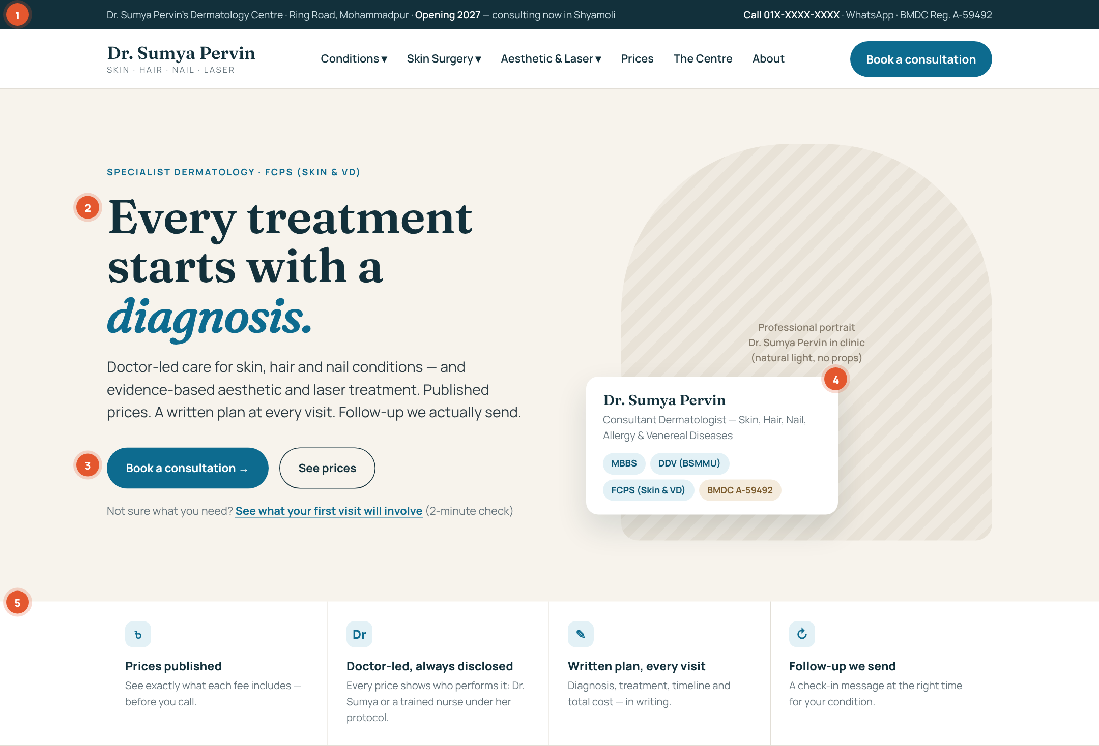
Home — 1 of 4: utility bar, header, hero with credential card, four promises
# | Element | Behavioural purpose
1 | Utility bar with phone, WhatsApp and BMDC number | Authority and accessibility before scrolling; a verifiable registration number is a trust signal competitors omit.
2 | Hero headline “Every treatment starts with a diagnosis.” | Framing: answers the fear of being sold to before it forms.
3 | Primary CTA + “See prices” + a low-commitment third option | Commitment ladder: three entry points for three levels of readiness.
4 | Credential card overlapping the portrait | Authority made specific: degrees with institutions, plus the BMDC number.
5 | Four promises strip | Risk reversal: each promise removes one documented market fear.

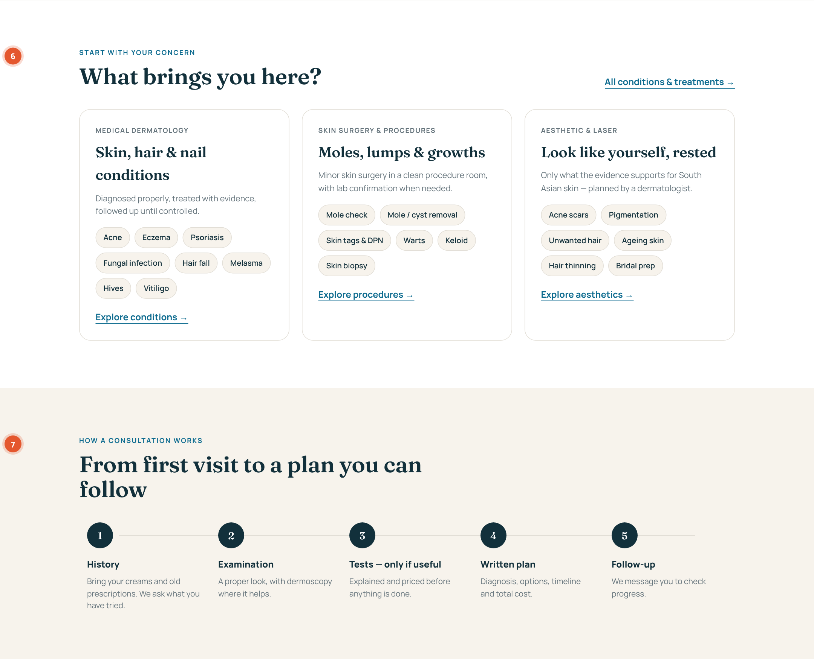
Home — 2 of 4: concern-first pillars and the 5-step consultation
# | Element | Behavioural purpose
6 | “What brings you here?” — three pillars with concern chips | Choice architecture: browse by problem, not by procedure; at most 3 options at the top level.
7 | Five-step consultation timeline | Reduces ambiguity aversion; shows that tests and costs are explained first.

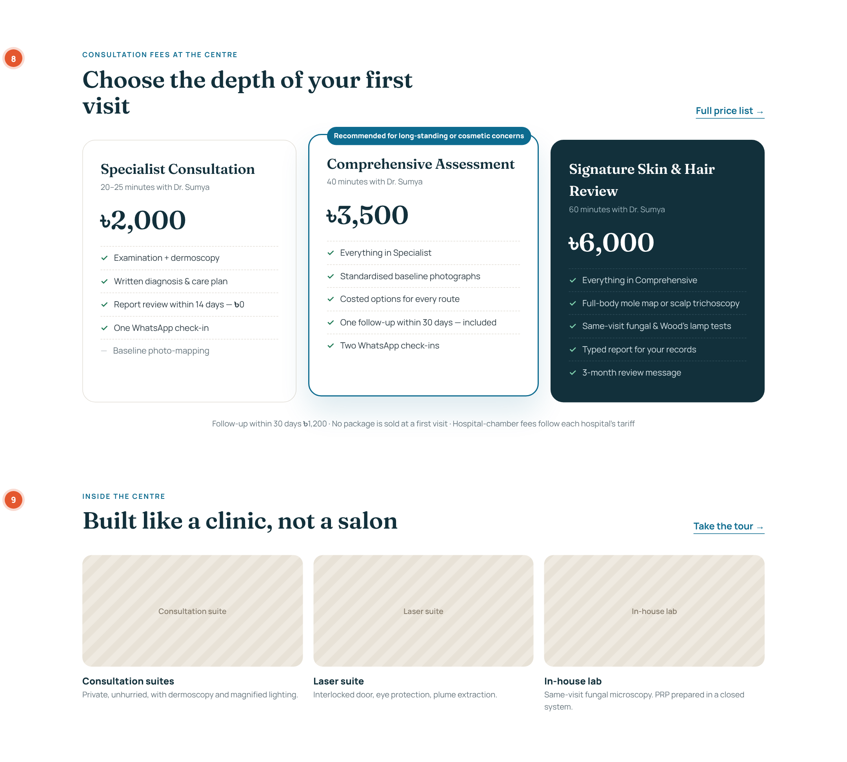
Home — 3 of 4: consultation tiers and the Centre preview
# | Element | Behavioural purpose
8 | Three consultation depths with inclusion lists | Compromise effect + value transparency; the dark Signature card acts as the premium anchor.
9 | Inside the Centre preview | Tangible quality cues justify premium pricing.

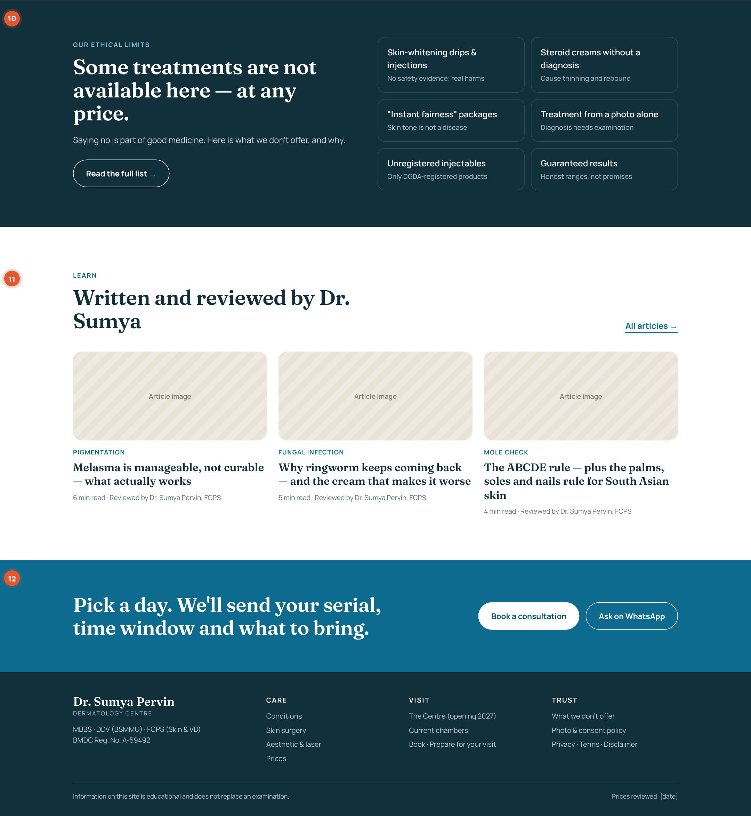
Home — 4 of 4: ethical limits, articles, final call to action, footer
# | Element | Behavioural purpose
10 | “Not available here — at any price.” | Costly signalling: refusing revenue proves integrity more than any claim.
11 | Bylined articles | Reciprocity and expertise (E-E-A-T for Google’s medical quality standards).
12 | “Pick a day…” final CTA | Implementation intention and the peak-end rule: a concrete next step plus a promise of what happens next.

7.2 Prices page
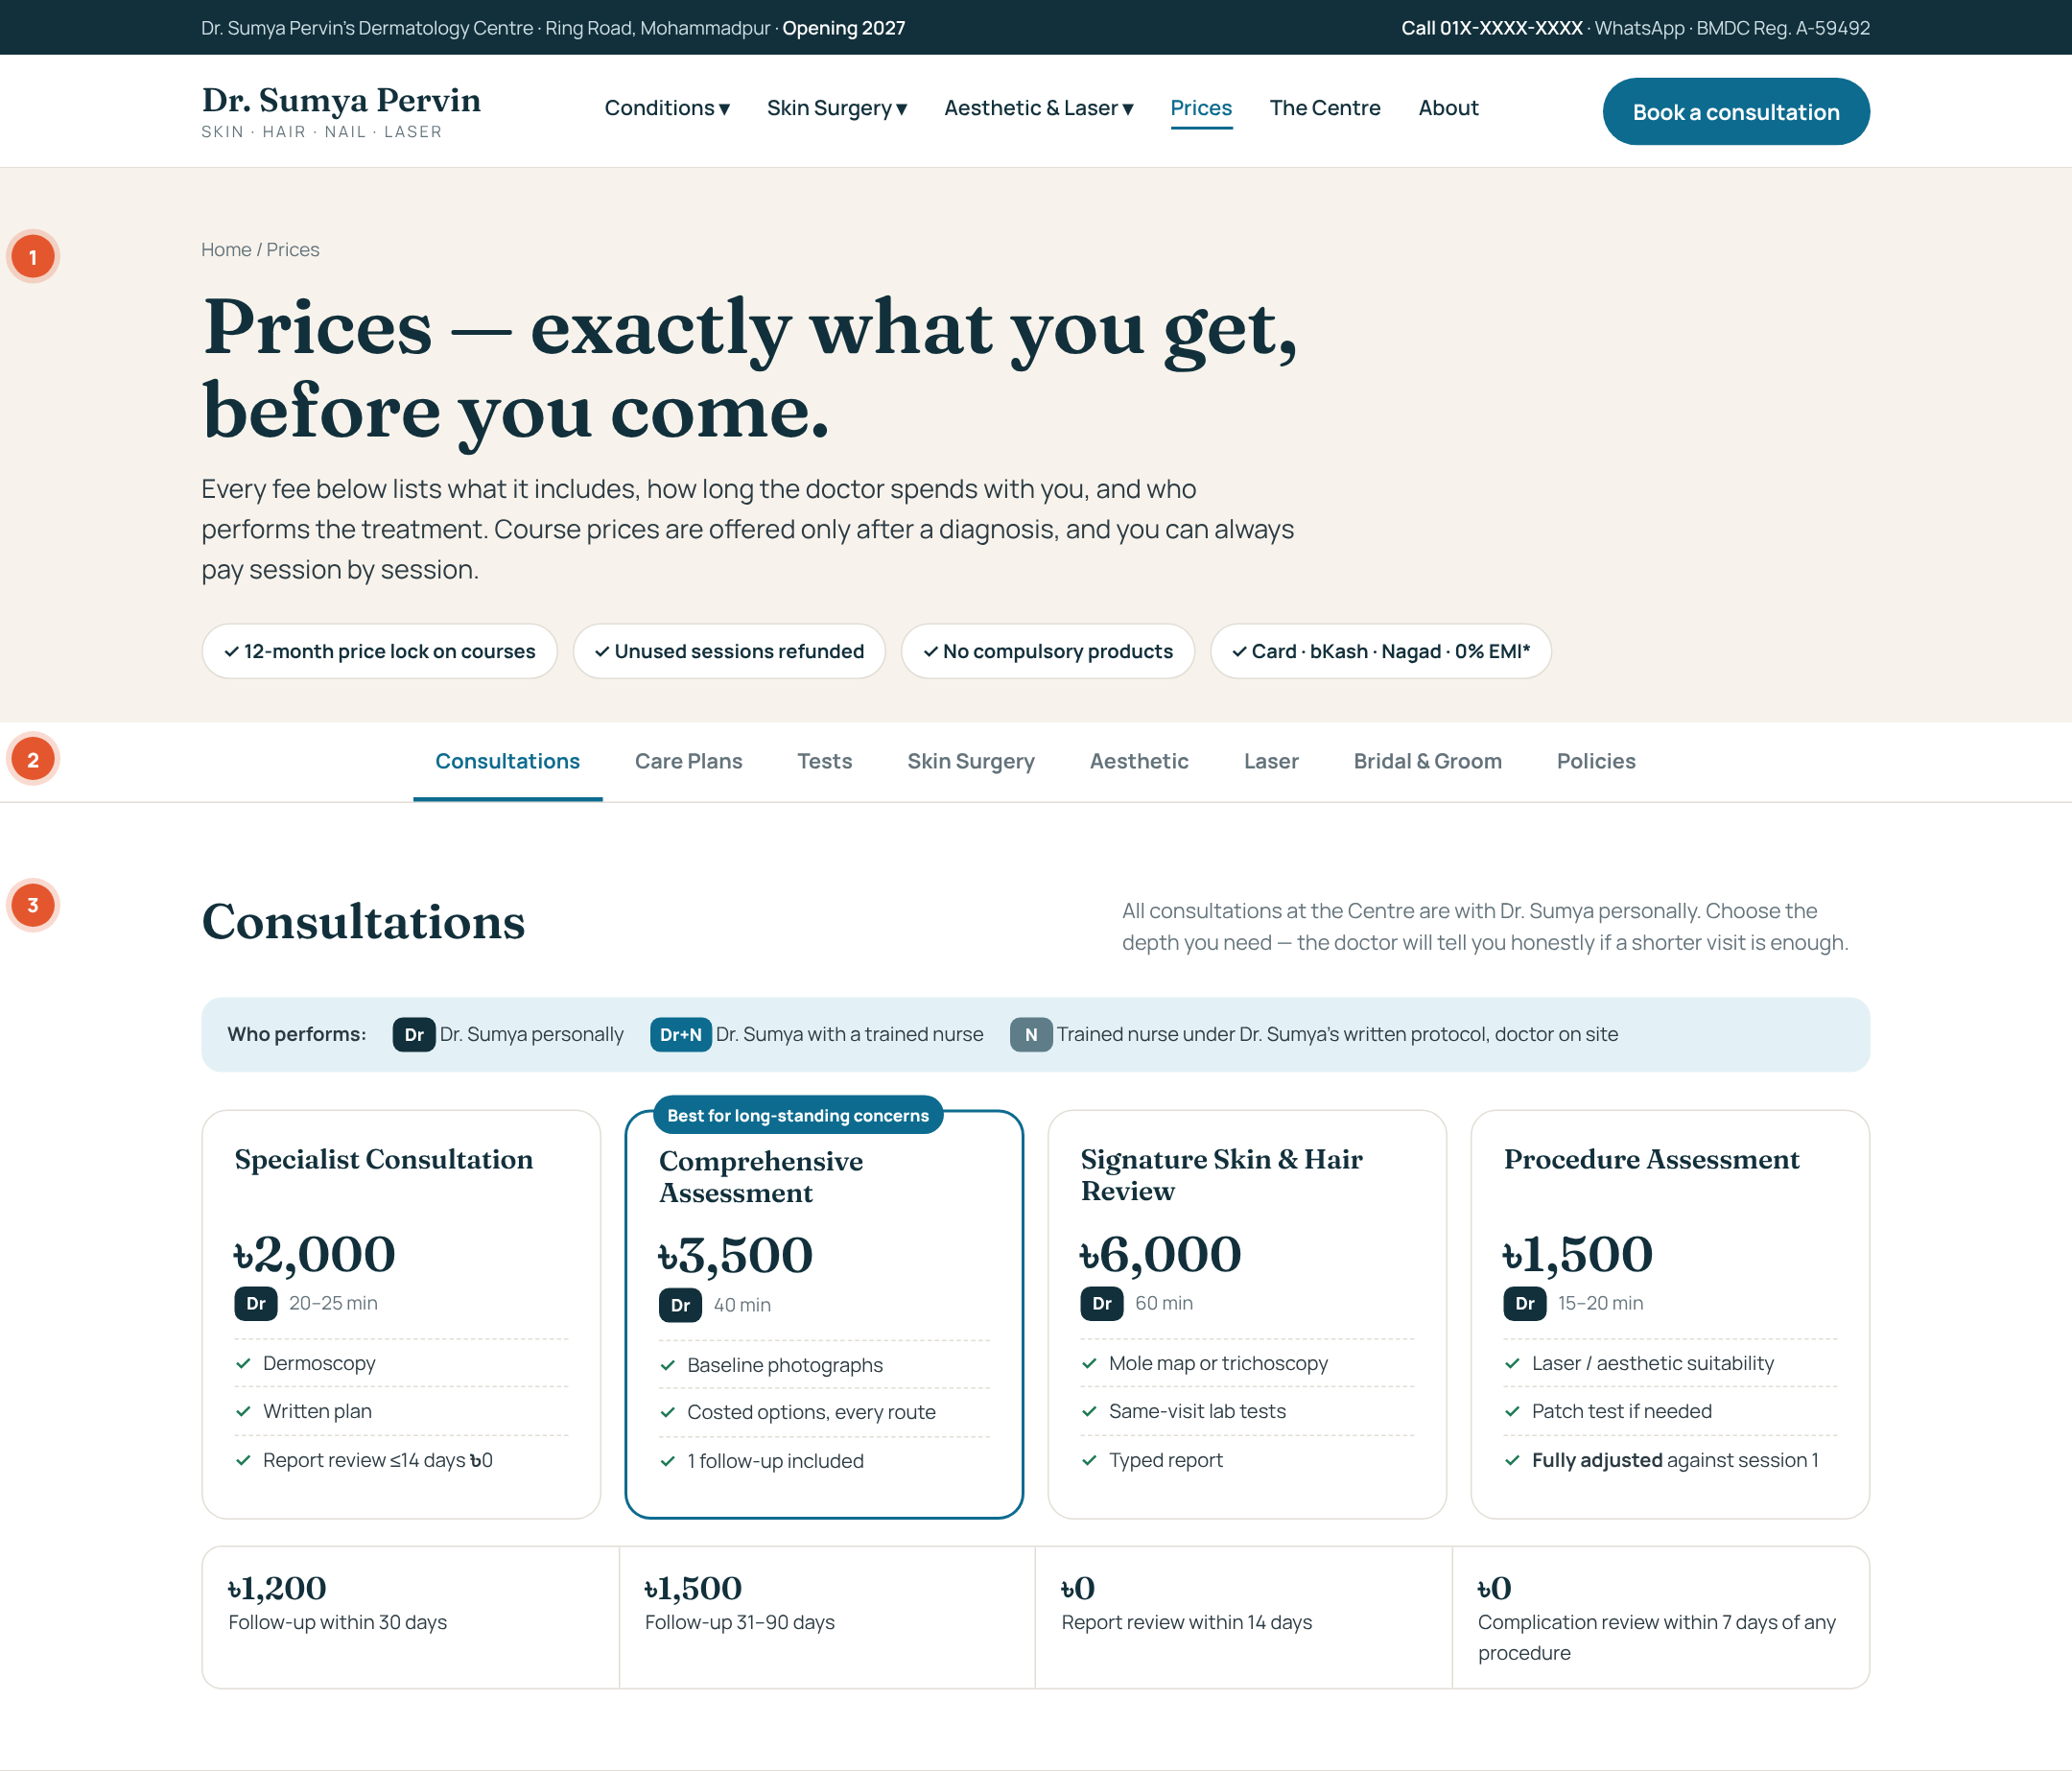
Prices — 1 of 3: promise, assurance chips, sticky tabs, consultation tiers with who-performs legend
# | Element | Behavioural purpose
1 | H1 + four assurance chips | Risk reversal up front: price lock, refunds, no compulsory products, payment options.
2 | Sticky category tabs | Chunking reduces choice overload; each tab unlocks only when its licence gate passes.
3 | Consultation cards + who-performs legend + follow-up strip | Operator disclosure and ৳0 items (zero-price effect).

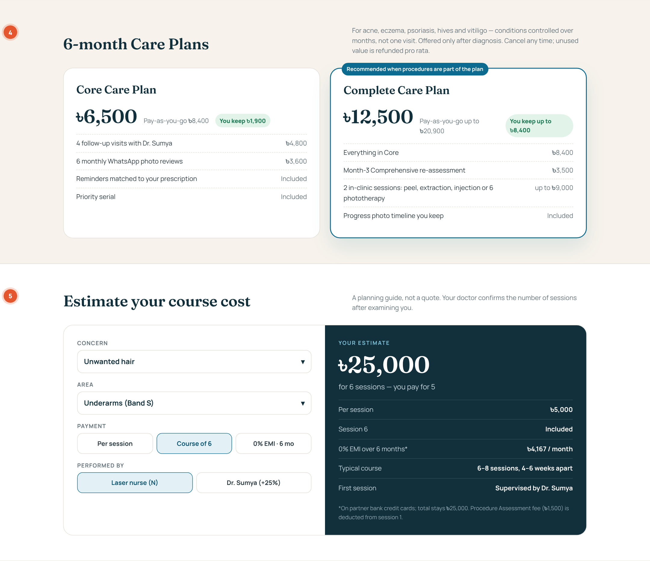
Prices — 2 of 3: Care Plans with real anchors, and the course estimator
# | Element | Behavioural purpose
4 | Two Care Plans with itemised value and “You keep ৳…” | Honest anchoring and mental accounting; recommended plan tied to a clinical condition.
5 | Course estimator | Simulation removes uncertainty; shows total, per-session, free session, EMI and operator together.

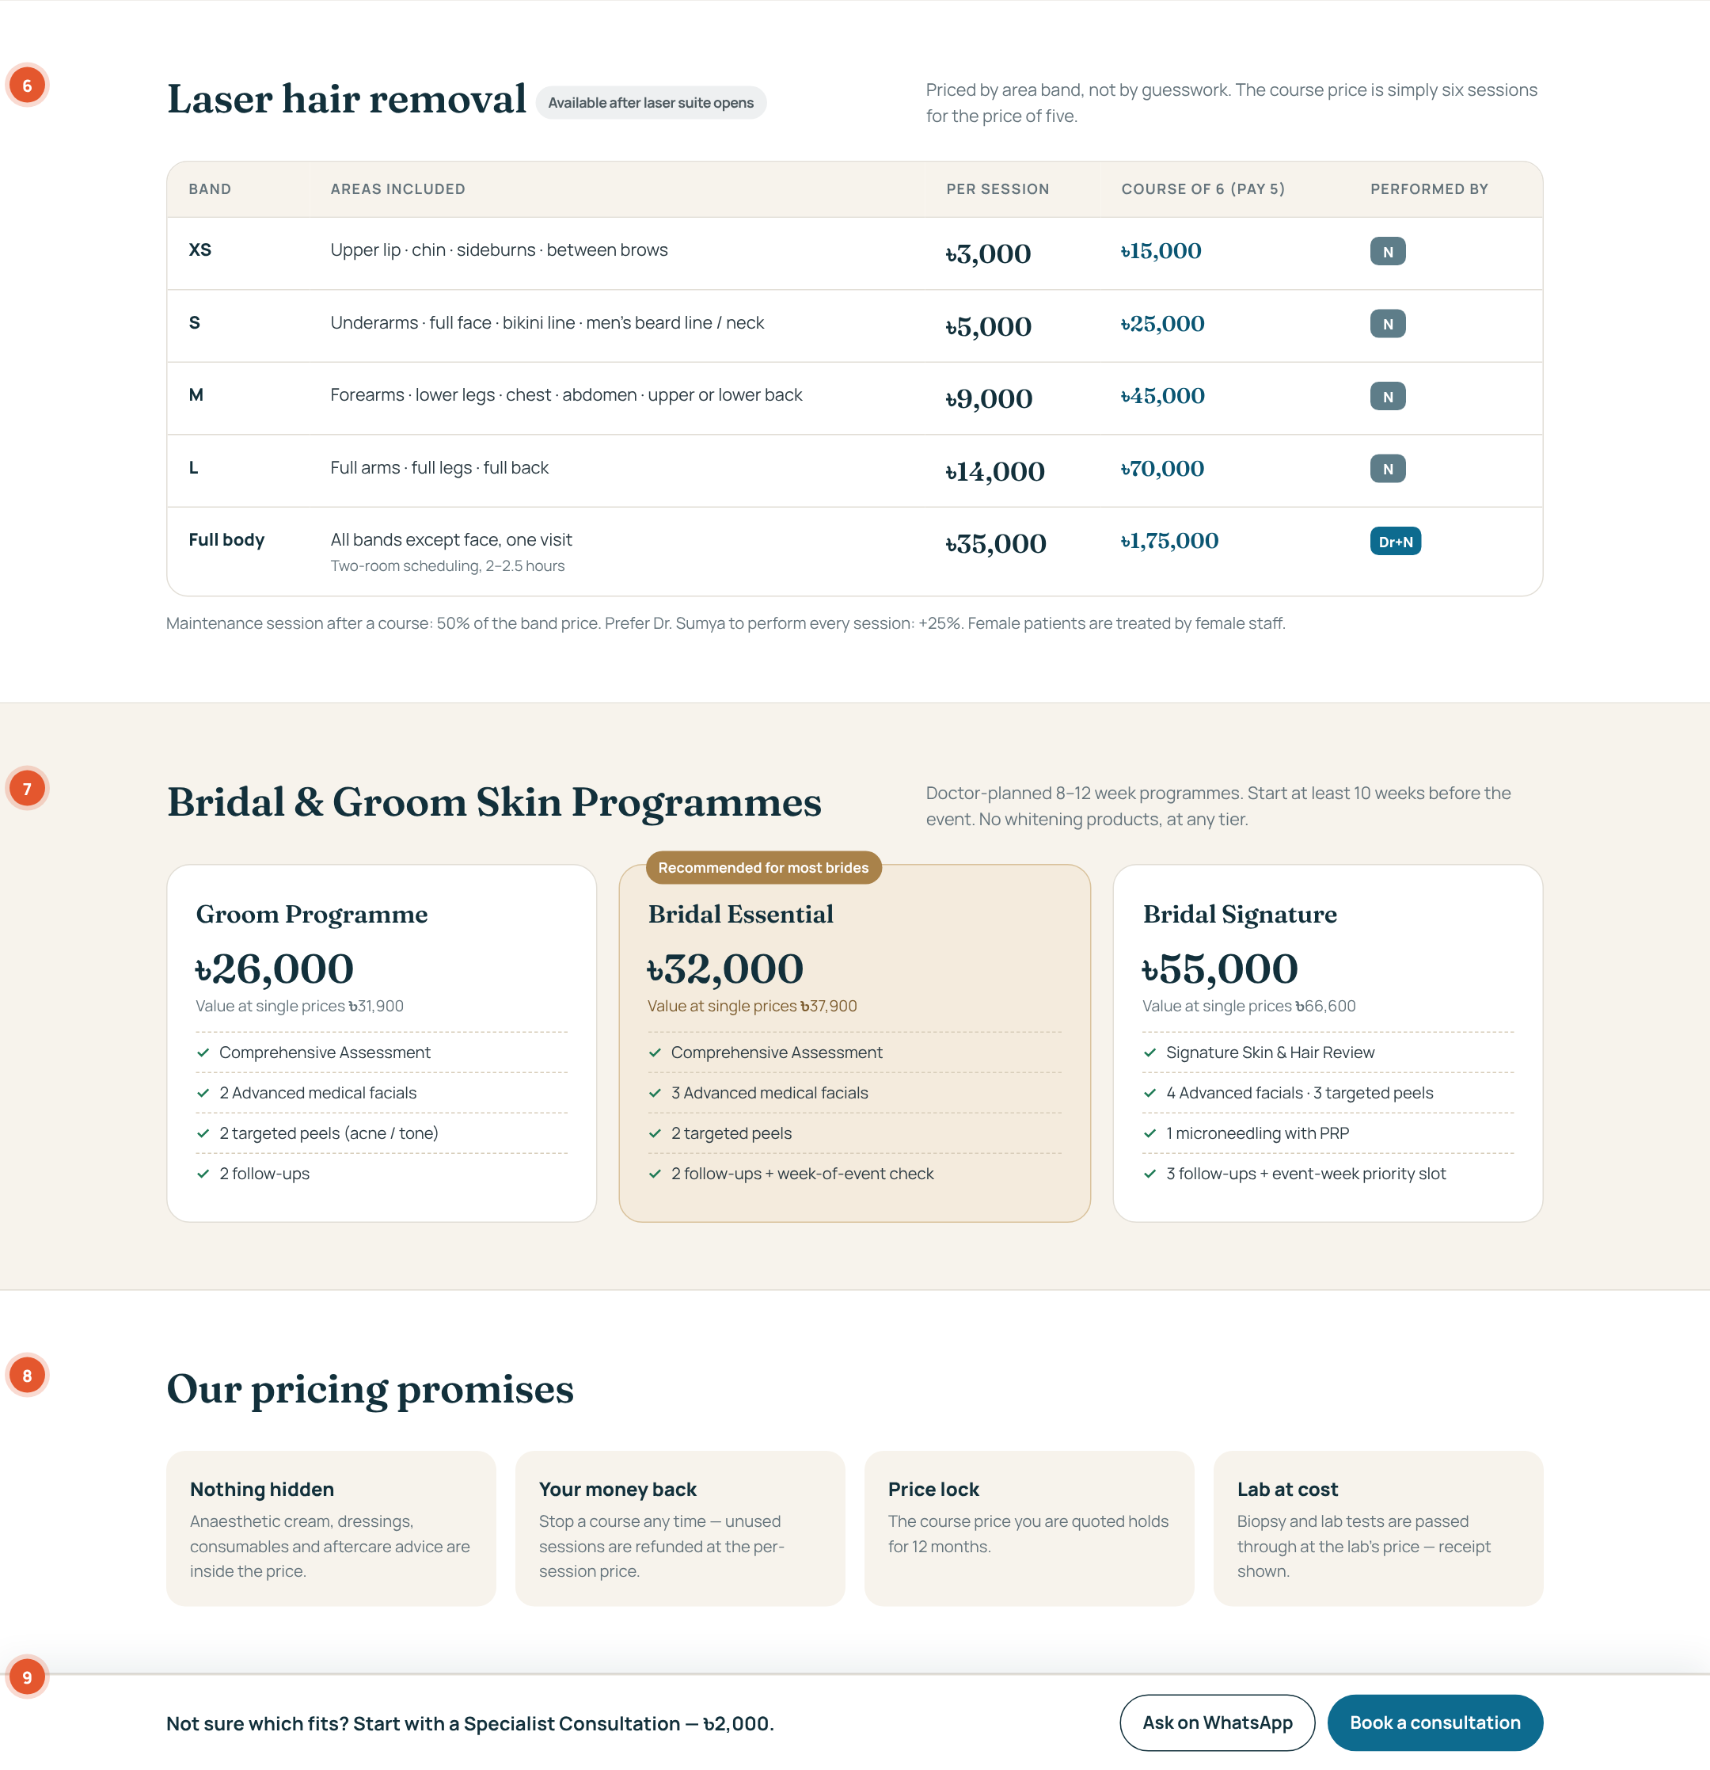
Prices — 3 of 3: laser area bands, bridal tiers, pricing promises, sticky booking bar
# | Element | Behavioural purpose
6 | Laser area-band table with course column | Self-pricing by band; bonus framing (“pay 5”).
7 | Bridal tiers with “value at single prices” | Compromise effect with a real anchor; event-driven demand.
8 | Pricing promises | Final loss-aversion relief just before the decision.
9 | Sticky bar: “Not sure? Start with a Specialist Consultation” | Default to the lowest-risk step; WhatsApp as the softer alternative.

7.3 Mobile rules (most Dhaka health searches are on mobile)
- Single column; consultation and plan cards stack with the recommended card first on mobile.
- Price tables become stacked cards: band name → price → course price → inclusions (expandable) → who-performs badge.
- Sticky bottom bar on every page: Call · WhatsApp · Book (44 px minimum tap targets).
- Tabs become a horizontal scroll strip; the estimator becomes a 4-step wizard.
- Target: Largest Contentful Paint under 2.5 s on a 4G connection; hero image under 150 KB (WebP/AVIF).

Part 8 — Global-standard checklist
Area | Standard to meet
Clinical content (E-E-A-T) | Byline with credentials and BMDC number on every clinical page; “last reviewed” date; 2–4 references to recognised guidelines (BAD, AAD, NICE, EADV, WHO); medical review every 12 months; no claims without a source.
SEO | One H1 per page; title ≤ 60 characters; meta description ≤ 155 characters; descriptive slugs; breadcrumbs; XML sitemap; internal-link rulebook (Part 3.4); Google Business Profile for the Centre and each chamber.
Structured data (schema.org) | MedicalClinic and Physician (with medicalSpecialty: Dermatology) on Home/About; MedicalCondition on condition pages; MedicalProcedure on treatment pages; FAQPage on FAQs; Offer/PriceSpecification on Prices; BreadcrumbList sitewide.
Accessibility | WCAG 2.2 AA: text contrast ≥ 4.5:1, focus visible, alt text for every image, captions on videos, form labels, keyboard navigation, no information by colour alone (who-performs badges carry text).
Performance | Core Web Vitals “Good” on mobile: LCP < 2.5 s, INP < 200 ms, CLS < 0.1; self-hosted or preloaded fonts; lazy-load below-the-fold images.
Privacy & data | Consent for messages and photos; minimum data collected on booking; encrypted forms; patient right to access and delete; compliant with Bangladesh’s Personal Data Protection Ordinance 2025 and aligned with GDPR principles.
Photographs & results | Signed consent per image and per use; fixed lighting and background; no retouching; region crops; label with treatment, sessions and time since treatment; withdraw-consent link.
Regulatory | BMDC Code of Professional Conduct (factual, non-promotional, no superlatives); no service advertised before its DGHS licence gate; products under the Drugs and Cosmetics Act 2023; devices and injectables DGDA-registered.
Security | HTTPS, admin/CMS not linked publicly, rate-limited forms, daily backups.
Analytics (GA4 events) | book_click · whatsapp_click · call_click · price_tab_view · estimator_complete · tool_complete (mole, skin type, prep) · booking_submitted. Monthly dashboard: conversion by entry page, by pathway, and by price tab.

Part 9 — Decisions for Medical Director sign-off
ID | Decision | Recommendation | Needed by
D-01 | Consultation fees: ৳2,000 / ৳3,500 / ৳6,000; follow-up ৳1,200 / ৳1,500 | Approve; update tracker Config (was ৳1,500 / ৳1,000) | Before price board print (T7-01)
D-02 | Procedure Assessment ৳1,500 credited against session 1 | Approve | LICENCE gate
D-03 | Care Plans (Core ৳6,500 / Complete ৳12,500) | Approve for acne, eczema, psoriasis, hives, vitiligo, hair loss, melasma | OPENING
D-04 | Mystery-shop 6 clinics to validate the price list | Do before publishing any procedure price | Before LICENCE
D-05 | Laser bands and “6 for 5” course; +25% for doctor-performed | Approve; confirm with laser device cost per session | Laser contract (T5-05)
D-06 | Drop exosome, carboxytherapy and mesotherapy pages | Approve: weak evidence, conflicts with ethics page | Now
D-07 | Botulinum toxin and fillers not at launch | Approve; revisit at Day-90 | Day-90 review
D-08 | Bridal & Groom programme prices | Approve; launch for wedding season | LICENCE
D-09 | Female staff for female laser patients; chaperone policy | Approve and roster accordingly | Staffing plan (T6-01)
D-10 | 0% EMI partner bank(s) | Approach 2 banks via POS provider | T9-04
D-11 | Monthly free screening hour (Community) | Approve, first Saturday | OPENING
D-12 | Centre name, phone, address, photos | Needed for every page | T1-01 / lease

Next step
Once D-01 to D-06 are signed, hand Parts 3, 5, 6 and 7 with the HTML layouts to the web developer as an addendum to Developer Change Request v1.0. Publish in gates: doctor pages and condition pages now; Centre and consultation prices at OPENING; procedures at LICENCE; laser at LASER.

